

MedEire – Medical Appointment Web Application Hosted in AWS

Final Project Report

DT211C – Year 4

BSc in Computer Science (Hons)

**Abraham Izarra**

**C19340801**

**Supervisor: James Carswell**

School of Computer Science

Technological University, Dublin

**2022 - 2023**

Abstract

The main purpose of this project is to provide a technical solution, through a single online medical appointment application. MedEire is created to offer a range of features and services, designed to support medical staff and patients. It improves their time management using different tools such as providing online medical appointments, task managing, internal live chat, and access to medical records.

The benefits of this web application are multiple but the main one is to support users save time, enhance services, and decrease medical staff workload.

Declaration

I hereby declare that the work described in this dissertation is, except where otherwise stated, entirely my own work and has not been submitted as an exercise for a degree at this or any other university.

Signed:



_________________________

Abraham Izarra

15/03/2023

Acknowledgements

Many thanks to my supervisor, James Carswell, for his consistence guidance and feedback throughout this project, this was invaluable and incredibly helpful to complete this project.

I would like to thank my mom, Anyi for supporting me throughout my career and life and always been there for me when I needed her, I could have not accomplished so much without her.

<https://www.instagram.com/reel/ClWSngEjSZC/?igshid=YmMyMTA2M2Y%3D>

Table of Contents

1. Introduction 11

1.1. Project Background 11

1.2. Project Description 13

1.3. Project Aims and Objectives 13

1.4. Project Scope 13

1.5. Thesis Roadmap 13

2. Literature Review 15

2.1. Introduction 15

2.2. Alternative solutions to addressing online medical scheduling needs 15

2.2.1 Barnaclinic+ 15

2.2.2 Johns Hopkins Medicine 16

2.2.3 LetsGetCheck 17

2.2.4 Eirdoc 18

2.3. Technologies you have researched 21

2.3.1 React 21

2.3.2 React Router 23

2.3.3 Node.js 23

2.3.4 AWS 25

2.3.5 Relational Database Service (RDS) 27

2.3.6 S3 29

2.3.7 EC2 30

2.3.8 SES 31

2.3.9 Amplify 31

2.3.10 Socket.io (Live chat) 33

2.4. Other Research you have done 33

2.4.1 Frameworks / Libraries 33

2.4.2 Cloud Services 34

2.4.3 Databases 35

2.5. Existing Final Year Projects 36

2.5.1 CloudFirst: a chatbot & dashboard for modern deployment pipelines 36

2.5.2 Heart healthy 37

3. System Design 38

3.1. Introduction 38

3.2 MedEire Architecture 38

3.3. Software Methodology 39

3.3.1 Other Methodologies Researched 40

3.3.1.1 Waterfall Methodology 40

3.3.1.2 RAD Methodology 41

3.4. Overview of System 41

3.4.1 Patient usage scenario: 43

3.4.2 Doctor / Nurse / Secretary usage scenario: 44

3.5. Conclusions 44

4. Testing and Evaluation 45

4.1. Introduction 45

4.2. Plan for Testing 45

4.3. Plan for Evaluation 45

4.3.1 Patient’s Manual: 45

4.3.1.1 Registration / Login 45

4.3.1.2 Account Management 46

4.3.1.3 Appointment Creation 46

4.3.1.4 Edit / Delete Appointment 46

4.3.1.5 Medical Records: 47

4.3.2 Medical Staff Manual: 47

4.3.2.1 Registration / Login 47

4.3.2.2 Account Management 47

4.3.2.3 Appointment Creation 48

4.3.2.4 Edit / Delete Appointment 48

4.3.2.5 Medical Records: 48

4.3.2.6 Task Manager: 48

4.3.2.7 Internal Live Chat 49

4.4. Conclusions 49

5. MedEire Development 50

5.1. Introduction 50

5.2. MedEire Development 50

5.2.1 Patient Role Screens 52

5.2.2 Medical Role Screens 57

5.2.3 Admin Role Screens 62

5.3 MedEire Code: 63

5.3.1 Login 63

5.3.2 Registration 64

5.3.3 Navbar 64

5.3.4 Account Management 65

5.3.5 Home 66

5.3.6 Appointment Creation 67

5.3.6 Appointment Management 68

5.3.7 Medical Records 69

5.3.8 Live Chat 70

5.3.9 Authentication 71

5.3.10 Role Management 72

5.4 AWS Services 73

5.5. Conclusions 77

6. Issues and Future Work 78

6.1. Introduction 78

6.2. Issues and Risks 78

6.2.1 Budget 78

6.2.2 Security 78

6.2.3 Time 78

6.2.4 Registration Email (authentication) 78

6.3. Plans and Future Work 79

6.3.1 Home emergency 79

6.3.2 Add online payment: 79

6.4 GANTT Chart 80

6.5 What Would have been done differently. 80

Bibliography 81

Table of figures

Figure 1: Comment explaining the patient experience (translated to English from Spanish) 15

Figure 2: Barnaclinic+ confirmation page proving no appointment was made 16

Figure 3: Johns Hopkins Registration activation code 17

Figure 4: LetsGetCheck dashboard showing its multiple tools. 18

Figure 5: Eirdoc Home Page 19

Figure 6: Eirdoc Requesting an Appointment 19

Figure 7: The State of JS 2021. The graph is partitioned by usage of each library and the year [7] 22

Figure 8: Web Frameworks and Technologies / Node.js most common web technology in 2022 [9] 24

Figure 9: Cloud Provider Market Share Trend / Demonstrating AWS growth in the previous year’s [11]. 26

Figure 10: MedEire Database Tables 28

Figure 11: MedEire Architecture Design Using React, NodeJS and AWS services. 39

Figure 12: Patient UML Diagram 42

Figure 13: Doctor, Nurse, and Receptionist UML Diagram 43

Figure 14: MedEire’s Login Page 50

Figure 15: MedEire’s Registration Page 51

Figure 16: MedEire’s Patient Sidebar Menu 52

Figure 17: MedEire Patient Account Management Page 53

Figure 18: MedEire Patient Home Page 53

Figure 19: MedEire Patient Appointment Page 54

Figure 20: MedEire Patient Update Appointment Page 55

Figure 21: MedEire Patient Medical Records Page 56

Figure 22: MedEire staff Sidebar 57

Figure 23: MedEire Staff Account Page 58

Figure 24: MedEire Staff Home Page 58

Figure 25: MedEire Staff Live Chat Page 59

Figure 26: MedEire Staff Appointment Page 59

Figure 27: MedEire Prototype’s Staff Update Appointment Page 60

Figure 28: MedEire Staff Side ‘Medical Records’ Page 61

Figure 29: MedEire Staff Task Manager Page 61

Figure 30: MedEire Admin Settings Page 62

Figure 31 MedEire Login and Authentication Code 63

Figure 32: MedEire Registration Email Code 64

Figure 33: MedEire Navbar Menu Code 64

Figure 34: MedEire Account Management Code 65

Figure 35: MedEire Home Code 66

Figure 36: MedEire Appointment Creation Code 67

Figure 37: MedEire Patient Manage Appointment Code 68

Figure 38: MedEire Medical Records Code 69

Figure 39: MedEire Medical Records Code 70

Figure 40: MedEire Authentication Code 71

Figure 41: MedEire Role Management Code 72

Figure 42: MedEire VPC 73

Figure 43: MedEire EC2 73

Figure 44: MedEire RDS 74

Figure 45: MedEire IAM Users 74

Figure 46: MedEire IAM Roles 75

Figure 47: MedEire SES 75

Figure 48: MedEire S3 76

Figure 49: MedEire Amplify 76

Figure 50: MedEire Gantt Chart Showing the Implementation Dates of Features and Tools 80

Table of Tables

Table 1: Functionality Comparison Table 20

# 1. Introduction

MedEire is a medical web application designed to increase the efficiency of scheduling and managing medical appointments for patients. MedEire offers medical personnel the benefits of lowering their workload by having all the necessary utility and features in one app.

Currently in Ireland, medical appointments cannot be scheduled or rescheduled online, and it is only possible to do so by calling or going to the GP. This can be a time-consuming process for the patients and the administrative personnel.

MedEire drastically reduces the time that patients normally spend when making an appointment, including the waiting time to be answered and the handling time. MedEire also decreases the workload of administrative personnel as it will not be necessary to manually create or manage an appointment when a patient contacts them.

MedEire is not revolutionary in any way because similar applications have been created in many other countries, such as ‘Johns Hopkins Medicine’ a medical appointment website in USA. However, MedEire is an application that offers a vast range of features and tools within a single application that introduces a level of improvements to the technology currently used. MedEire is hosted in the cloud using AWS, therefore it is possible to update and upgrade the application very easily and implement all the technologies that are currently in use into one application instead of having to use multiple applications in the browser or computer.

## Project Background

This research aims to collect information and acknowledge the current systems that provide online medical appointments used by medical staff and patients. The goal is to gain a better understanding of the existing needs or if whether it is necessary to implement or improve the system that is currently in use.

In Ireland, there seems to be a lack of technological innovation in the online medical appointment scheduler domain in which one single application contains all the necessary tools and features that are needed for this process. Although there are considerable number of websites that perform the same purpose in other countries, this type of application does not yet appear to be used in Ireland.

MedEire is created to offer the most necessary tools and features in a single application to support medical staff on administrative tasks. It is designed to improve time management but also offers a great solution to make online medical appointments, that patients can use as a self-service.

There is a real crisis being experienced by the health systems in Ireland and the UK, according to research and the references below.

Dr Diarmuid Quinlan, Medical Director of the ICGP, said “there was a need for protected time for GPs to deal with the increasing mountain of paperwork that comes with the job, explaining that six hours of clinical work could generate up to four hours of paperwork”. [2]

Dr Omon Imihi, Gp in St Helens, said "there's this notion that the GP receptionists are difficult to get through, but they can only offer what's there, they can only give what they've got". She worries about taking toilet breaks while trying to get through 18 face-to-face and remote consultations a day, on top of administrative work like processing prescriptions, blood test results and hospital referrals”. [3]

It is proven that it is essential to improve and spend less time on paperwork-related tasks and that time management affects medical staff. In this regard, implementing MedEire can lessen medical staff workload. The lack of an online app affects more than just the medical staff; it also makes it harder for patients to make an appointment and communicate over the phone. This issue faced by thousands of patients struggling to get through a call to make an appointment can be reduced by utilising MedEire.

The research below shows that most patients lament spending hours or days on hold while waiting to speak to someone on the phone in addition to the lengthy wait times during the call to get an appointment. Additionally, some patients would rather visit the clinic in person than wait in line to speak with a doctor.

“More than a quarter of patients who need appointments avoid making one because they find it too difficult, according to a new survey.” The NHS GP Patient Survey [3]

“The [NHS](https://www.nhs.uk/) [GP Patient Survey](https://www.gp-patient.co.uk/) 2022 showed a sharp rise in people struggling to get through to GP practices over the phone. Since last year, the share of respondents saying it was not easy to contact anyone jumped by nearly 15 percentage points to roughly 47% in the previous 12 months”. [3]

Even in jest, the frustration of multiple patients is depicted, although it is a genuine issue that affects many citizens.

“Social media is full of memes about the obstacle of a GP's receptionist and the struggle of the 8am phone queue for a same-day appointment. But behind the humour is falling patient satisfaction and a growing struggle to access what is, for many, the first port of call for medical help, revealed this year by the survey”. [3]

How long do you have to wait to get a GP appointment? was one of multiple questions added to a survey by The Irish Examiner.

“The Irish Examiner is looking to speak with people struggling to find a GP or to get an appointment on a timely basis”. [4]

The references mentioned highlight the need to cut back on waiting and paperwork time. Medical staff would benefit from an online application that helps them manage their time more effectively so they can deal with their patients' immediate needs and supply higher-quality care. Time is valuable for everyone, so it's crucial to use it on the things that matter most.

One of the improvements suggested in the reference below is improving the appointment system:

Dr Howsam of RCGP said, “our patients – and our GPs and practice teams - deserve better. That's why the College has launched our Fit for the Future campaign calling on government to address the spiralling workload and workforce pressures in general practice.”

"We want urgent action to improve patients' experiences, including investment into IT and booking systems, alongside a new recruitment and retention strategy that allows us to achieve and go beyond the target of 6,000 more GPs. We also need to see a reduction in unnecessary bureaucracy, so that GPs can spend more time delivering care to patients.” [3]

With this research it is conclusive that an application such as MedEire is very necessary to improve medical workers lives and the technology. MedEire can bring benefits such as self-service scheduling, rescheduling, cancellation, and appointment support. This can be achieved by streamlining patient scheduling and enhancing staff productivity by reducing the time needed to do tasks such as sending medical records, task managers, and allowing internal live chat functionality.

## Project Description

MedEire contains different webpages that offer different tools and features to help in the creation of medical appointments and supports medical personnel to increase their efficiency by having all the needed tools in one single application instead of requiring multiple apps.

MedEire contains a login and registration page which changes the tools that the user can interact with depending on their account (medical personnel or patient)

The appointment creation page, with its triage, date and time, description, and the doctor.

The current appointments’ page allows the user to reschedule their appointment.

If the user logged in is medical personnel, MedEire offers a live chat and a task manager, to provide a smoother communication between them and request the completion of tasks needed.

And lastly, medical records page that allows medical personnel to upload the records to the patient account which they will receive an email notification; and a download function which is enabled only if the patient user has uploaded their written consent and their photo ID.

## Project Aims and Objectives

The overall aim of MedEire is to innovate how medical appointments are scheduled, by creating an application that contains all the tools and features needed by the medical personnel.

To accomplish MedEire’s main goal, there are various milestones that need to be achieved:

* Create the main page.
* Create registration / login / account management.
* Create ‘schedule an appointment page’ allowing updates and cancellation of appointments.
* Send notifications when appointment has been created.
* Create internal live chat.
* Task manager
* Upload and download medical records.

## Project Scope

As for now MedEire does not have a prescription page or a payment page. If the application gains more popularity or customers, there are plans to implement these two pages to further increase the productivity of the application and support medical personnel in their daily work routine.

MedEire is not an application with the option of video or phone consultation, it does not contain the option to order medical testing equipment and deliver it to the patient’s home, also it is not an application to self-diagnose as it does not contain any information of patient’s symptoms.

## Thesis Roadmap

The system is covered in detail in the system design chapters, which also provide an overview of the system, a description of its architecture, a discussion of the methodology employed and other methodologies that were investigated, and user scenarios with UML diagrams.

The literature review is divided into four sections: alternative solutions to the problems raised throughout the report, it discusses the technologies used to develop MedEire, research on alternative technologies and discusses existing final-year projects that are like this one or use similar technologies.

The testing and evaluation chapter explains the importance of testing the application, the strategy for assessing the application and the user manuals that will be handed to testing users when evaluating the application.

The prototype development analyses the prototype screens, features, and behaviours for MedEire, it contains both the staff and patient screens and explains the utility of each.

Finally, the issues and future work chapter explains the problems encountered while working on the project, the future work planned for after MedEire is finished and more well-known, and the completion dates Gantt chart.

# 2. Literature Review

## 2.1. Introduction

This research intends is to determine which current systems are used by medical professionals and patients. The primary objective of this chapter is to identify alternatives that are currently in use throughout the world. It presents four existing web applications and descries their different and similar services offered as a solution. It also makes a comparison to MedEire to provide a solution to these problems.

## 2.2. Alternative solutions to addressing online medical scheduling needs

### 2.2.1 Barnaclinic+

Barnaclinic+ [1] is a branch of the Hospital Barnaclinic of Barcelona responsible for medical treatments not covered by the public health system.

In this investigation, the reviews of some patients made in social media have been taken as a reference most of the comments are always positive about general services offered by the clinic, however there was no specific mention of the application used by the clinic.

Only one patient mentioned his experience about the online medical appointment system[2] (Figure 1), he commented that one of the difficulties that he had while he was a patient was receiving a delayed email to schedule the appointment.

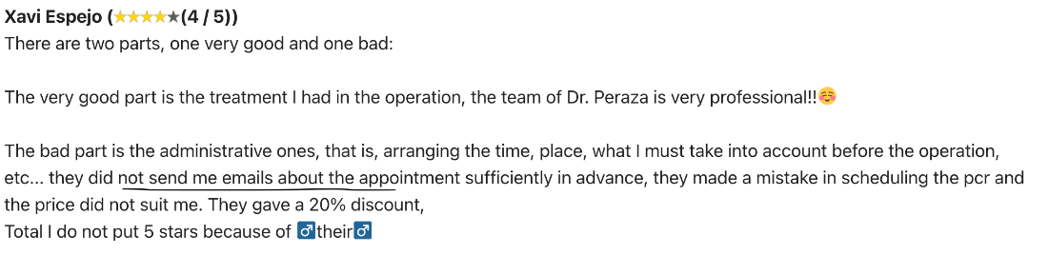

###### Figure 1: Comment explaining the patient experience (translated to English from Spanish)

As there was no conclusive evidence of their web app reducing the issues already mentioned, research was conducted by navigating their page from a user perspective, concluding, and identifying the key elements that Barnaclinic is missing.

The application does not allow the patient to schedule a booking by specifying the date and time of the appointment, this really implies that the patient does not self-manage the medical appointment instead they must wait to be contacted by the administrative staff to schedule the appointment.

Another important missing feature is the registration and login to prevent users from creating false appointments using fake information or personal details.

The following image (Figure 2) is the confirmation created by Barnaclinic+ when an appointment was created. Confirming that there is no appointment assigned, and the user must wait to be contacted to add it to a real schedule or calendar.

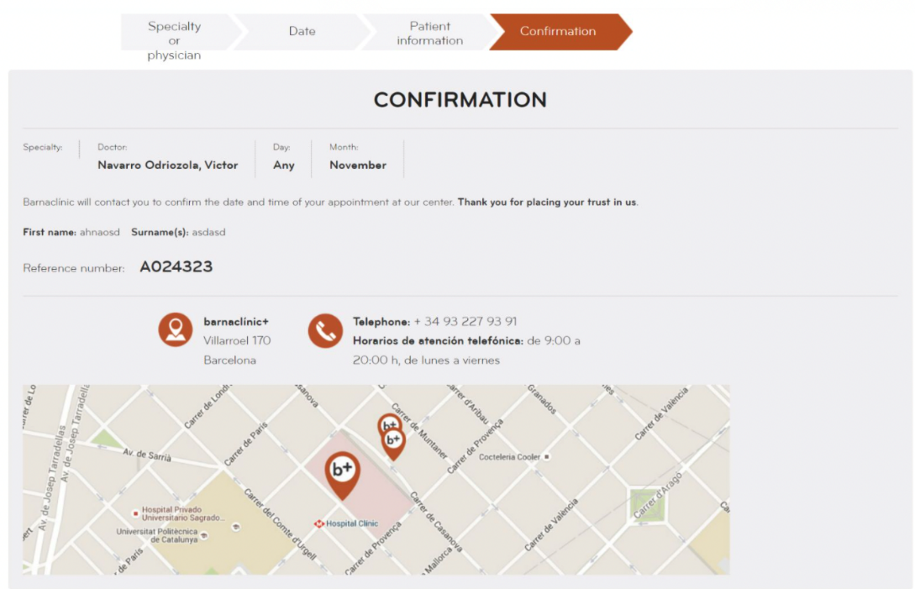

###### Figure 2: Barnaclinic+ confirmation page proving no appointment was made

Nevertheless, the alternative of having a system that allows patients to reserve their slot to be contacted through email or through a phone call, seems to be a suitable alternative for most patients. There is no evidence of complaint or any criticism in delays for not having prompt attention to the online medical appointment system.

### 2.2.2 Johns Hopkins Medicine

The Johns Hopkins Hospital is the teaching hospital and biomedical research facility of the Johns Hopkins School of Medicine, founded in Baltimore, Maryland, U.S.

The online medical appointment system of the Johns Hopkins Medicine [3], presents quite friendly characteristics for the patient, the online appointments have self-management functionality to assign dates and times allotted to the patients.

It also follows security measures to avoid the request for online medical appointments from patients who are not real. to register on the page a user must have a previously assigned activation code as shown in the below image (Figure 3).

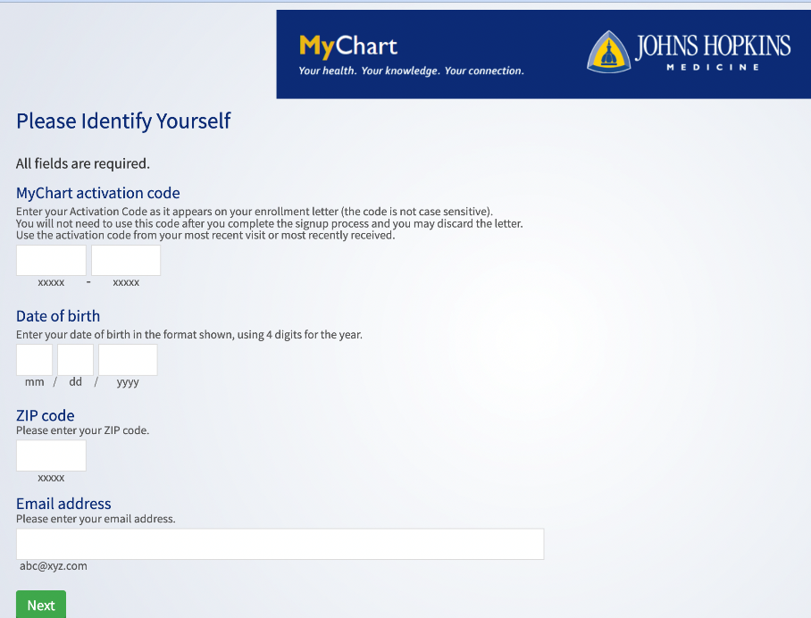

###### Figure 3: Johns Hopkins Registration activation code

Other important tools found are the following:

* Access your test results.
* Request prescription renewals
* Video Visits from Home
* [Your Medical Record](https://www.hopkinsmedicine.org/patient_care/mychart/mychart-faqs.html#record)

### 2.2.3 LetsGetCheck

LetsGetCheck is a web application based in USA, UK, and Ireland. It “builds and delivers at-home testing kits including hormone tests, fertility tests, HPV tests and wellness tests for cholesterol and diabetes.” [4]

The creation of the user is quite simple and patient friendly to navigate as shown on the following image (Figure 4).

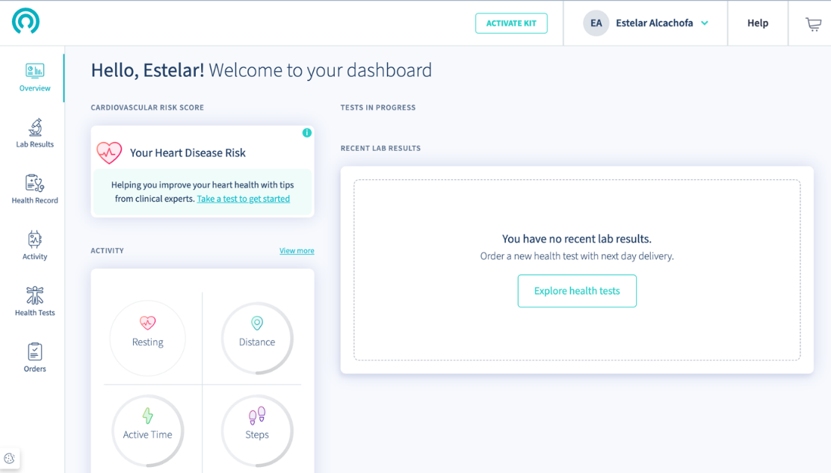

###### Figure 4: LetsGetCheck dashboard showing its multiple tools.

LetsGetCheck It is an alternative online system that “supplies a vertically integrated platform that supports the full spectrum of patient care, providing direct access to diagnostic testing, genetic insights, virtual consultations, and medication delivery. The global company offers a complete end-to-end solution for patients with access to more than 100 laboratory panels and personalized treatment plans” [5].

### 2.2.4 Eirdoc

‘Eirdoc’ is a medical appointment website based in Ireland, this app can only schedule appointments for video or phone consultations (Figure 5). It also contains a prescription page which is locked by having to create an account with them; in this page medical staff can send the patient’s prescriptions into pharmacies across Ireland using ‘Health mail system’.

The online platform allows the doctors to supply prescriptions, referral letters and sick notes at their discretion in a seamless manner. This application is quite simple and easy to use as seen in (Figure 6).

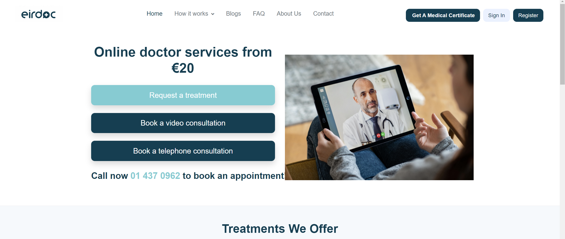

###### Figure 5: Eirdoc Home Page

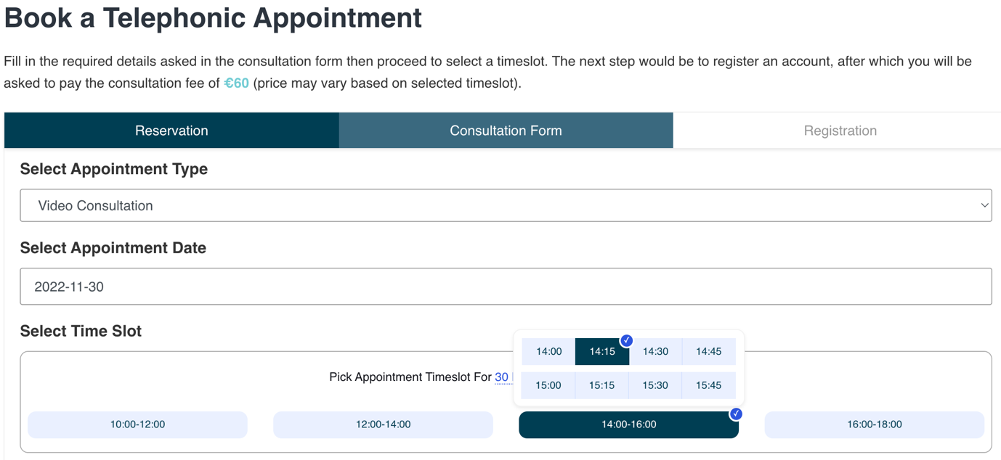

###### Figure 6: Eirdoc Requesting an Appointment

Below is a functionality comparison table (Table 1) between the above-mentioned medical appointment applications and the application proposed in this project. It shows that competing applications have taken a different approach from MedEire to solve the issues researched.

The most similar web application to MedEire is ‘Johns Hopkins Medicine’ that has various useful tools and features implemented in a single app, the biggest difference between these two applications would be the architecture of the systems.

Table 1: Functionality Comparison Table

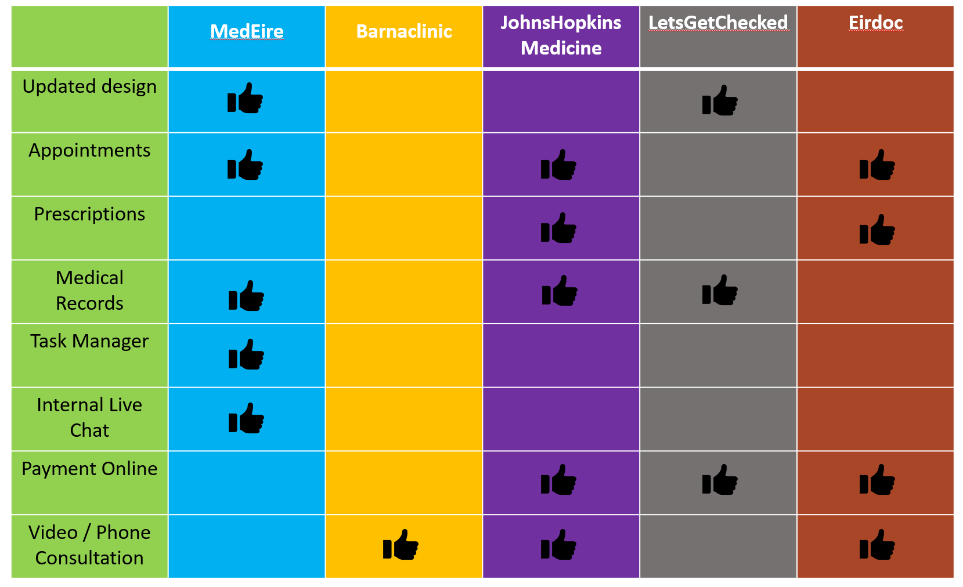

MedEire, using all the features listed above in (Table 1), provides a solution to the issues found. It is the main reason that this web app makes the appointment process more efficient and supports medical personnel by reducing their workload.

Johns Hopkins Medicine: is the most similar web application to MedEire, this application offers various useful tools and features implemented in a single app, also both offer self-managing online medical appointments, medical records access. The biggest difference between these two applications would be the architecture of the systems and Johns Hopkins Medicine’ has access to prescriptions, offer online payments, and video call consultation.

Barnaclinic: Is the web application that has less similar features with MedEire, Barnaclinic does not allow the patient to schedule a booking by specifying the date and time of the appointment, this really implies that the patient does not self-manage the medical appointment instead they must wait to be contacted by the administrative staff to schedule the appointment. It also offers video call consultation, while MedEire offers online self-managed appointments, access to medical record, task manager and Internal live chat.

LetsGetChecked: Delivers self-testing kits to patients. This app stores medical records, online payments, and a mobile application. The only similarity now to MedEire is the ability to store medical records.

Eirdoc: this app provides self-service online medical appointment like MedEire, but the differences are that Eirdoc offers video phone consultation and prescriptions and online payments. MedEire does not, rather MedEire offers internal live chat, task manager and access to medical records.

## 2.3. Technologies you have researched

This section analyses the technologies used to create this application, by answering the following questions: what they are, a brief background, pros & cons, why are they used in the tech industry and why MedEire uses them over other technologies.

### 2.3.1 React

React is a free open source, front end JavaScript library for building user interfaces based on different components. React was developed and maintained by Meta, it was firstly introduced by using the ‘Stack’ method which was slow to display complex animation as it was trying to conduct all the animations in one chunk. It was then updated to use the ‘Fiber’[6] method which divides the animations and the structure of the page into different segments that can be spread out over multiple frames, this allowed React to display a smoother rendering process and gain popularity in the tech industry. [5]

There are multiple advantages to using React for the development of a web application and these would explain why the tech industry uses React for countless web applications, for example: [7]

* React can be used for creating cross-platform products, it supplies ease of development for web and mobile applications (using React-Native) using the same syntax that was used for the web application, this reduces the cost significantly as there is no need to develop different applications.
* Backward compatibility, Although React is updated quite often the changes that they provide most of the time does not affect the React API and when they do they provide plenty of time to migrate the code without breaking the application.
* ​Reusable components, React allows pieces of the UX to be developed and the joint to create more complex UX.
* Virtual DOM (Document Object Model), improves an app performance because the virtual DOM implementation compares changes in the app and re-renders only the changed parts of the app.

React offers various advantages but there are also disadvantages that requires the developers to research other technologies, these disadvantages are for example:

* Based on 3rd party libraries, React is a library and there are no official libraries to manage common features such as routing, http request, etc.

Even the most popular libraries that can implement these features into a React app can also have versions conflicts in which the libraries are changed and can break the application developed using these technologies.

* Lack of convention, although this can be thought to be a small disadvantage, it forces development teams to spend time discussing common development rules for a project, mostly when the development team may change multiple times, it results in a messy code because everyone has different coding habits.

[6]

According to a study done by Sacha Greif and their team [7], collecting more than sixteen thousand (+16,000) responses. React was the most used JavaScript Library in the past years, this is a result of the great advantages that React offers and although it has its own disadvantages, using React to create any application provides one of the smoothest animations, as well as ease of creation for complex UX, and an easier way to create mobile and web applications in the technology industry. All these traits allowed React to stay in the top libraries and being used by the biggest companies such as: GitHub, Facebook, Instagram, Netflix, and many others.

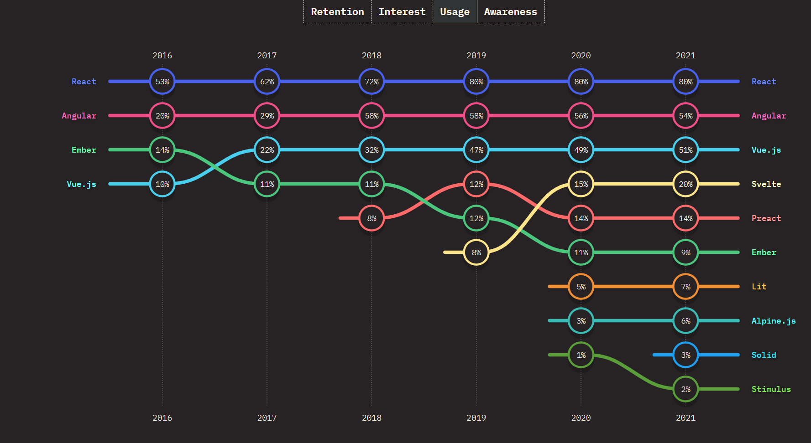

###### Figure 7: The State of JS 2021. The graph is partitioned by usage of each library and the year [7]

Above (Figure 7) is a graphic by Sacha Greif and their team proving the results of their survey, the graph is partitioned by usage of each library and the year. They describe the usage to be calculated by their survey answers (‘would use again’ + ‘would not use again’) / total responses.

Having read about React’s pros & cons, its usage in the industry, and how it works. We can now discuss the reason MedEire uses this technology over any others in the industry. MedEire is a web application that is designed to solve the current lack of technological advancement in Ireland of online medical appointments. Despite MedEire not being a completely original application as there are other web applications worldwide with the same purpose, these applications are outdated with a lack features. [8]

MedEire use React as many of the biggest applications online uses them and there are many reasons to use this technology over others as React offers high performance with a quick response, smoother animations which in turn equals a greater overall website experience, it also allows MedEire to be easily implemented in a mobile application in the future using ‘React Native’ and when MedEire gains more popularity it can be easily maintained by other developers as React is such a popular technology that many developers have knowledge on how to use this library.

To continue reading more on the other technologies researched for MedEire and the reason they were not chosen for this project, see the ‘Frameworks / Libraries’ section.

### 2.3.2 React Router

React Router is used to provide the browser with an asynchronous URL corresponding to the data displayed on the web app. It is used to create single page web applications as it keeps the normal structure and functionality of the application. In an application, React Router is used to define different routes, e.g. When a user enters a URL in a browser and the URL path is one of multiple "paths", such as a router directory, the user is redirected to that path. [9]

In addition to the performance benefits, there are also other benefits such as:

* Routing between components is fast because the amount of data to display is small. The DOM displays the rest of the data, and while there is a huge amount of HTML and CSS to display, the DOM manages it.
* Easily make animations and transitions when switching between different components for a better user experience.
* Supplies a smoother and faster navigation as individual pages are not rendered, and the current page is does not refreshed to load different views.

There are also disadvantages to using React router, these are: [10]

* Initial load time is quite long, as all routes, components and HTML must be loaded simultaneously. If there is an unexpectedly incorrect rendering of a page, it takes an unnecessary amount of time to download the data.
* Requires an external library. This means more code and dependencies on external packages than routing on the server.

MedEire uses React router as it is outstanding when redirecting a page and keeping the user interface synchronized with the view and supplies a smoother animation transition. Although it takes a longer time to load when the application is opened the difference is not notable.

### 2.3.3 Node.js

Node.js is an open source and cross platform JavaScript framework and library that can be used to make network web applications on a server. Developers use it to build backend web applications because it uses an event-driven asynchronous model, which is ideal for data-intensive applications. Ryan Dahl created it in 2009, and it is still one of the most widely used in the tech sector. [8]

There are multiple benefits to using Node.js when creating a web application, which would account for the widespread use of it, including the following: [11]

* Caching: Node.js stores data for future use. This means that data is retrieved from the cache whenever the user perform an action that requires it. This accelerates the process of developing apps.
* Easy Scalability, due to its asynchronous and event driven nature it is easier to scale applications created with it making Node.js perfect for high performance and real-time applications.
* Easy to Learn, Node.js uses JavaScript, which makes it easier to understand for developers of all skill levels and enables the use of many other libraries to integrate behaviours that are not already included.
* Single Language, JavaScript is a language used for both client side and server-side scripting, while most other programming languages accomplish the same thing. As a result, it is simpler to create, distribute, and maintain web applications using Node.js.

However, there are also disadvantages associated with using Node.js [12]

* Unstable API, Since Node.js does not offer a stable APIs, programmers who need to write API-required programs are faced with many difficulties.
* Could slow down, although capable of performing CPU-intensive tasks, Node.js was designed to operate in a single thread. In other words, only one request can be managed simultaneously.
* Multiple dependencies, due to Node.js lacking a strong library support, developers must rely on third-party libraries to support tasks that are absent from the core Node.js library.

Below (Figure 8) is a survey conducted by Stack Overflow and their team [9] in 2022 with around sixty-thousand responses from all over the world. This study shows that Node.js is still used by developers of all levels and is still one of the most relevant frameworks in the tech sector.

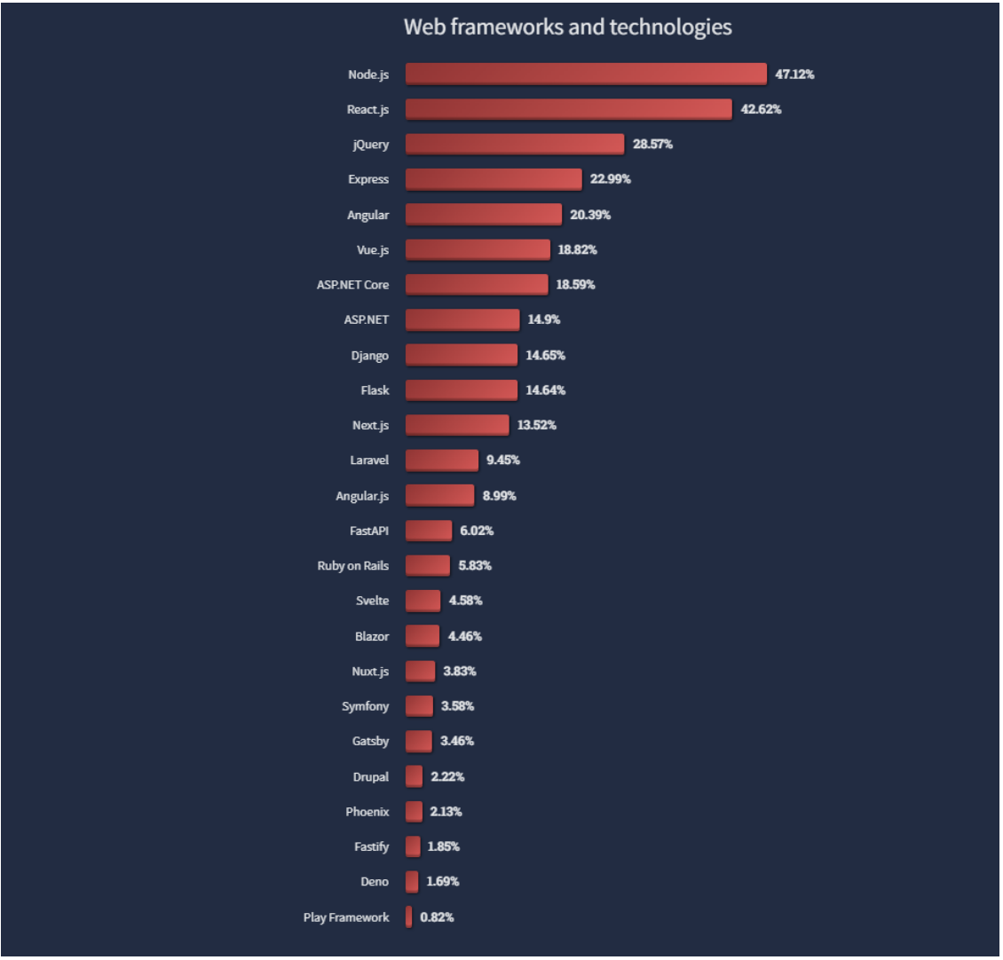

###### Figure 8: Web Frameworks and Technologies / Node.js most common web technology in 2022 [9]

Node.js can continue to rank among the top technologies because of its multiple benefits, including caching, which improves app performance, and its simplicity in creating complex applications using just one language. Node.js is not perfect, but its flaws can be worked around by combining frameworks and/or libraries.

Because of the multiple benefits that NodeJS can offer any web application, including caching and ease of scalability that perfectly complements AWS auto scalability and could be implemented in the application if it becomes more successful, MedEire chose to use it as one of its technologies of use. In MedEire, NodeJS is currently being used to build the server and back-end data that make it simple to connect the RDS database with the React front-end framework.

### 2.3.4 AWS

AWS is a cloud computing platform provided by Amazon that includes Infrastructure as a Service (IaaS), Platform as a Service (PaaS), and Software as a Service (SaaS). AWS offers compute power, database storage and content delivery services.

Amazon used these services internally to build the infrastructure of their own website and it began offering infrastructure as a service (IaaS) using a pay as you go model that scales providing its users with compute and storage as needed. This payment model was a first in the cloud services and allowed Amazon to attract various interested users and gain renown in the tech world. [10]

There is a vast list of advantages that AWS provides its customers in the development of any application such as: [13]

* Payment model, Amazon has the pay as you go model which only ask its customers to pay for the services they used, this was a first in the cloud providers making AWS one of the most cost-effective cloud services in the market.
* Fast and scalable, AWS proved that they are a reliable way to deploy any application within minutes in such a way that allow its services to scale up and down in such an effortless way that it reduces time spent, cost and increases efficiency and agility.
* User friendly, AWS is easy to use as the platform is specially designed for quick and secure access, it provides all the information, documentation, and video instructions to support in the creation of most applications or learn how to use their services.
* Security, AWS provides a highly secure infrastructure to ensure the privacy of its customer’s data and has multiple methods to guarantee this security such as: identity and access management, infrastructure protection, threat detection.

AWS ensures that the customers should not need to worry about their confidentiality and instead they allow them to focus on business development.

AWS has its own disadvantages that developers must understand when creating an application using Amazon’s services, these are: [14]

* Price variations, even though AWS uses the pay as you go payment model, there are price variations depending on the cost of land, fiber, electricity, and taxes from region to region which can increase or decrease the prices of the same services and the same app in different areas.
* Lack of experts, although there are multiple developers that understand the basics of AWS, it is constantly growing every day and implementing new services which takes time to learn how to use them and write the appropriate documentation.
* Technical support fee, AWS charges a different fee for their technical support which can be quite costly when adding these services fees and the technical support fees.

According to the research done by ‘Synergy Research Group’ (Figure 9) Amazon’s cloud services continue to grow and remain in the top against other companies such as Microsoft or Google; Amazon can stay ahead of their competitors due to having all the advantages mentioned above, even if their services also have disadvantages, most developers see AWS as a growing opportunity that can more affordable than other cloud infrastructure services or buying the physical infrastructure. [11]

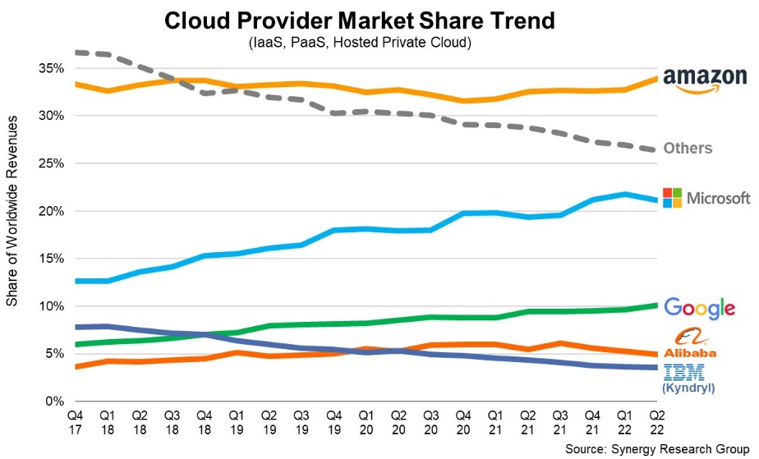

###### Figure 9: Cloud Provider Market Share Trend / Demonstrating AWS growth in the previous year’s [11].

Above a graph by ‘Synergy Research Group’ [11] demonstrates the market share of the multiple cloud infrastructure services, this graph is partitioned by growth percentage and the year (divided by quarters).

MedEire use AWS for multiple reasons, these reasons include the considerable number of advantages that AWS offers such as the flexibility of pricing, automatic scalability and most importantly the security aspect of using their services for a web application. Another important reason is the ability to connect the web application with the multiple services AWS offers such as S3 buckets, RDS, EBS, Lex, Connect, and more. This allow MedEire to continuously grow and be updated when extra features or tools are needed.

To continue reading more on the other technologies researched for MedEire and the reason they were not chosen for this project, see the ‘Cloud Services’ section.

### 2.3.5 Relational Database Service (RDS)

MedEire uses Relational Database Service (RDS) to store login information from users and to store the S3 path to an S3 bucket containing the images the users need to upload and download, RDS is a relational database owned by AWS, RDS is ran in the cloud and it was designed to facilitate the creation, use and scaling of a relational database for applications. The management processes such as patching database, backups and scaling storage or compute can be done with API calls to AWS. RDS offers the most popular engines in the tech industry for relational databases such as Amazon Aurora, MySQL, MariaDB, PostgreSQL, Oracle, and Microsoft SQL Server. [12]

Using RDS as the main database service for an application brings considerable number of advantages[15], such as

* Automatic software patching, RDS ensures that the relational database software used in the app deployment is up to date with the latest patches.
* Scalability, RDS allows provisioning additional memory as the memory requirements grow. Amazon Aurora automatically increases the database volume size up to 64 TB or a user defined maximum, this storage scaling is provided with zero downtime.
* Availability and durability: RDS provide automatic backups and point in time recovery for the user’s data, this saves up the database and the transaction logs and keeps both for a retention period specified by the user. Allowing the data to be restored up to the last five minutes, these automatic backups retention period can also be configured to up to thirty-five days.
* Security, AWS allows network isolation for the database using a VPC to control network access to the database instances and keep the data isolated from external connections. RDS also provides encryption in the databases using keys managed by the user with KMS (Key Management Service), this encrypts all the data stored, and the multiple backups created automatically.

RDS also has its drawbacks, just as any other technology and in this case the disadvantages are quite important to understand and keep in mind when creating any application using this service. [16]

* Lack of super privilege, while stored procedures take care of several operations, there are quite a few things that need to be learned when using RDS as it does thing in a unique way. This can also create problems in using external monitoring and trending tools.
* Lack of direct access to data directory and logs, makes it harder to perform actions which involves them. While it is possible to access those logs on RDS, it is more cumbersome than doing whatever you need by logging into shell on the MySQL host.
* Reduced insight into performance of your database. While you can get metrics from RDS itself, you are limited to what metrics are available in CloudWatch, AWS monitoring and trending tool. Any more detailed diagnosis requires contacting support and asking them to check and fix the problem. This may be quick, but it can also be an exceptionally lengthy process with a lot of multiple email communication.

MedEire uses MySQL engine in RDS which is a relational database because it can manage structured data or data with relationships between variables and objects. Relational databases also offer the below benefits which the project can also benefit from.

* Scalability, relational databases can scale vertically. This means it can increase the server load by upgrading CPU, RAM, or SSD capacity.
* Structured, relational database uses tables and rows of records with columns or attributes to organize data in a relational fashion.

When compiling a list of reasons why MedEire should and should not use RDS to store its data, the advantages offered by RDS outweigh its own disadvantages. MedEire is using a RDS from AWS because of the multiple advantages listed above, mostly the security and scalability aspects that AWS offers, this allows MedEire to continue growing and continue being secure for its customers and having minimal to no data breaches.

Below (Figure 10) are the tables needed for MedEire to function, this tables are stored in the RDS service using MySQL engine.

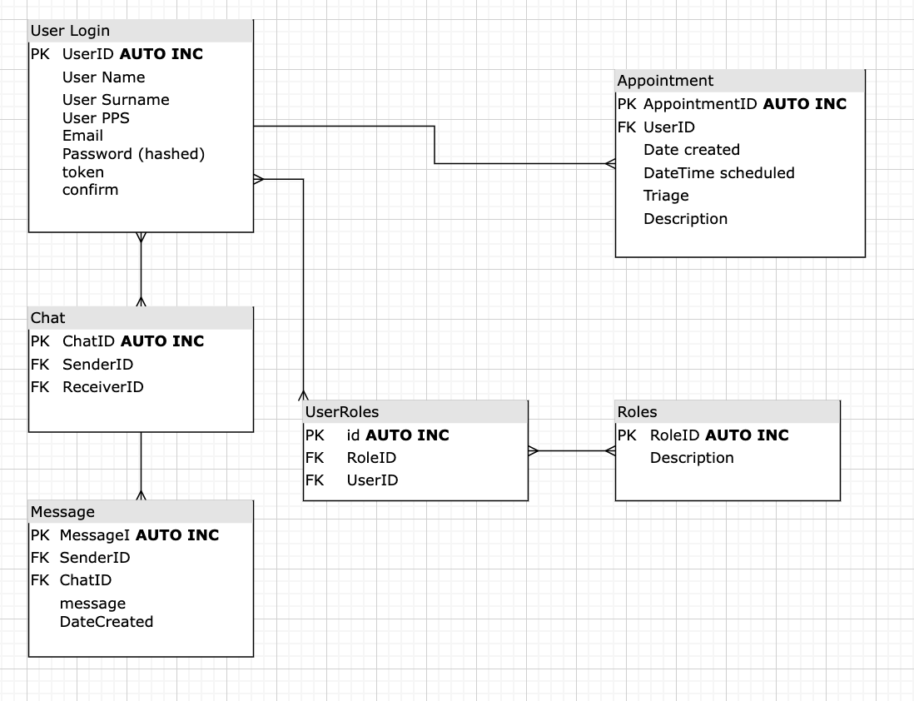

###### Figure 10: MedEire Database Tables

The "User Login" table; Contains the data needed to enable both the patient and the staff to register their accounts and login to their accounts.

The 'Appointment' table, which is also present in MedEire, is used to schedule appointments. It is dependent on the User tables and has a one-to-many relationship with them because a single user may have or create many appointments.

The "Roles and UserRoles" tables in MedEire store information about the different user roles available in the app. These roles are used to enable various access controls throughout the application, ensuring that users with specific roles can view and use certain features. For example, a user with the role of "Doctor" has access to the Live Chat feature, while a user with the role of "Patient" does not have access to this feature. By leveraging the roles and user roles tables, MedEire ensures that its users can only access the app's features that are relevant to their specific role.

Then there is the "Chat and Message" table, which store information like text messages, timestamps, sender/receiver, and other elements for the internal chats that staff members use. The chat table is dependent on the User table using a many-to-many relationship because of the role checks to utilise the live chat and because each staff member should be able to communicate with as many staff members as they choose, and the Message table is dependent on the chat in order to create the chat room and get information from which user the messages are coming from.

Some examples of the SQL code used to populate these tables are as follows:

* INSERT INTO User VALUES (1200, Abraham, Izarra, 1234, Abraham@email.com, *****, ‘token’, ‘1’);
* INSERT INTO Appointment (Patient-ID, Patient-Name, Patient-PPS, Staff-ID, Staff-Name) VALUES (1200, Abraham, Izarra, 1234, 2200, Dr David, Today, Check-up, Mild headache);
* INSERT INTO Chat (Chat-ID, senderID, receiverID) VALUES (9999, 2200, 1231);

More information on other technologies researched for MedEire and the reason they were not chosen for this project can be found in the ‘Databases’ section.

### 2.3.6 S3

Amazons Simple Storage Service (S3) is an object storage service that offers scalability, data availability, security, and performance. Any kind of file or data can be stored online indefinitely with this service. If you have an Internet connection, you can access the data stored in S3 from any location. The system is highly scalable and dependable if build correctly. You can use it to store data in your decentralized web application architecture, cheaply distribute content to the public, or keep your privacy secure. [13]

Below are some of the main benefits provided by S3 [17]

* Ease of Use, accessible anytime, anywhere, and specially designed for speed and security. Along with an easy-to-use interface that makes it simple to navigate the service, it also has a ton of tutorials, videos, and information to start using it.
* Unlimited Server Capacity, S3 provides limitless server space, letting you store data on it without being concerned about hard drive failures or service interruptions. Amazon S3 and AWS are dependable and scalable as needed with unlimited bandwidth.
* Reliable Encryption and Security, S3 provides high reliability as Amazon has many security measures to access the data stored within it, as well as different services that only allow certain IPs to access this data.

Despite all the advantages S3 offers it also has disadvantages that can make this technology not the most suitable for each application [18]

* Billing Can be Confusing, as with all AWS services the pricing for S3 can be complicated depending on many factors, such as how many Gb are used, how many GET, PUT, COPY, POST, LIST requests are used, which S3 type is used, and many others.
* Amazon’s S3 Limits, some regions may have fewer resources than others and inexperienced users are also restricted in the resources they can use and the amount they can spend.

MedEire uses S3 buckets to upload, download, and delete files because S3 is a method that is very secure and is safeguarded by Amazon’s multiple security methods and features. As well because this service is highly scalable and can be automated to scale when the application becomes a bigger success. MedEire opted to use this service as it can also be one of the less expensive file storage systems for storing a vast number of high-quality files and images.

### 2.3.7 EC2

Amazon Elastic Compute Cloud (EC2) is an online service that offers resizable computing in which applications can be run on the AWS infrastructure using their virtual server. There are multiple instance types, operating systems, and software options available for any usage necessary in different applications. EC2 also allow applications developed using AWS to be easily scaled with its many capabilities and automation as well as providing an extra layer of security to any application using the AWS virtual environment. [14]

EC2 provide an extensive list of advantages that benefit many applications and users below are some of the most important advantages provided by this AWS service:

* Elastic, you can scale up or down the application’s capacity with Amazon EC2 in minutes. Applications can also scale automatically based on demand.
* Resolute, Replacement instances can be deployed quickly and predictably in an extremely dependable environment thanks to EC2. The service is powered by Amazon's dependable data centers and network infrastructure.
* Secure, there are a multitude of safeguards offered by Amazon EC2 to protect the applications computing resources. AWS also allows configuring security system settings that regulate network access to instance groups, these compute services can also be isolated your by specifying IP ranges to use.
* Inexpensive, pay an exceptionally low rate for the compute capacity consumed by the user.

Although EC2 offers outstanding benefits one must also understand that EC2 also is not a perfect solution for all the applications, here are the major drawbacks:

* Price variations, multiple factors, including land, taxes, electricity, and fiber, have an impact on the price of EC2. As a result, to calculate the monthly bill, one must consider local prices as well as the application unique needs.
* Complicated, although AWS have extensive documentation on the usage of EC2 and other services, developers must learn how to integrate them together to achieve a secure, elastic, and inexpensive solution for their applications.

Even though using an EC2 can get expensive, for MedEire, it will be much less expensive and simpler to maintain than using other methods. MedEire uses EC2 because of its easy scalability, reliability, and other benefits that this service provides to applications. Additionally, because the majority of MedEire systems were already developed using AWS services, integrating those systems with their own compute services is much simpler and secure for the application's users.

### 2.3.8 SES

Amazon Simple Email Service (SES) is a service which allow sending multiple emails to any verified users. This service limits the emails that can be sent daily and by second, but it can be easily scaled by either requesting a different payment plan or by allowing the AWS automation to increase it. Email notifications of any kind and size can be generated programmatically using Amazon SES. You can use Amazon SES to send static and dynamic content of any size, from mass marketing campaigns to password reset emails. [15]

Here are the multiple advantages offered by SES: [19]

* High deliverability, Amazon offers support for the three authentication protocols (DKIM, SPF, and DMARC), putting a focus on reputation and authorization. You can manage your reputation and keep track of transfer activity.
* Content personalization, SES allow multiple designs and an easy personalization for the emails sent by this service.
* budget friendly, SES offers up to sixty-two thousand emails to be sent for free and after the threshold each one thousand emails are charged at $0.10 which is very inexpensive considering the quality of the service.
* Integration: SES integrates seamlessly with other AWS services.
* Reliability: the service can be integrated with different applications through SMTP interface.

More than disadvantages SES has limitations that need to be considered when implementing it into an application [20]

* Limited, SES limits the number of daily emails can be sent (up to two hundred on the free tier plan)
* Could become expensive, as with other AWS services SES price can change depending on varied factors such as if the emails have attachments, the number of emails sent daily or by second and other quantity of factors.

If MedEire has thousands of users, the task of sending multiple confirmation emails would become difficult and resource intensive for the application. SES offers a solution by allowing to send commands to SES via the AWS SDK without using the application's resources. SES only sends emails to verified users, so these emails will not end up in the spam folder, which would only cause more problems for MedEire's customers.

### 2.3.9 Amplify

AWS Amplify is a development platform that enables developers to build scalable and secure cloud-powered applications quickly and easily. It is a managed service offered by Amazon Web Services (AWS) that allows developers to focus on building the application instead of managing the underlying infrastructure. Amplify supports multiple programming languages and provides a set of pre-built UI components that can be easily integrated into applications. [16]

Using Amplify for an application brings many benefits, such as: [21]

* Rapid development, Amplify provides a set of pre-built UI components that can be easily integrated into applications, which helps developers to build applications quickly and easily.
* Security, Amplify provides built-in security features, such as authentication and authorization, to help developers build secure applications.
* Scalability, Amplify is highly scalable and can easily scale up or down based on the application load.

Amplify also has its drawbacks that need to be considered depending on the application created, these disadvantages are: [22]

* Limitations, Amplify may not support all of the features that a developer may require, which can limit the functionality of the application.
* Cost, Amplify is a paid service and the cost can increase as the application load increases.

Despite these drawbacks, MedEire chose to use Amplify due to its seamless integration with other AWS services and its ability to automate most of the features and tools developed for the application. This decision will be crucial for scaling the application quickly and easily. The limitations of Amplify have been considered, but they would not significantly affect MedEire because the application does not require any complex features that are not supported by Amplify. Additionally, the cost aspect would not be particularly impacted because the pricing is based on usage and the application does not require a high amount of usage.

### 2.3.10 Socket.io (Live chat)

A JavaScript library called Socket.io is used by real-time web applications to create the live chat for MedEire. Web clients and servers can communicate and send event-driven information with one another in real-time, in both directions. Socket.io is made up of a server library for Node.js and a client library that works in browsers. To establish connections and facilitate data transfer between clients and servers, socket.io uses Engine.io for server-side implementation, while engine.io-client is used for client-side implementation. [23]

Socket.io provides the below advantages: [24]

* Multiplexing, using namespaces can save socket ports on the server and cut down on the number of TCP connections.
* Flexible distribution, events can be broadcasted to every connected client.
* HTTP Long-Polling, in environments where web Sockets are not supported, it offers long HTTP requests as a practical fallback option.
* Ping/Pong, an adjustable mechanism is offered by Socket.io to help users determine whether a connection is active. A client will also automatically reconnect if it disconnects.

Although it has good advantages it also has the below disadvantages: [25]

* Few security features, Socket.io does not offer end-to-end encryption or a system for creating and updating authentication tokens.
* Latency if multi-regional, is not intended to operate in a multi-region architecture, but rather in a single region. When users are in different regions, this can result in issues like increased latency and system crashes.

Because socket.io is the quickest and most responsive library to send event-driven information, MedEire uses it to implement the internal live chat. MedEire also makes use of this technology due to the small number of resources required to create the internal live chat. Despite having a multi-regional design, MedEire's initial expectations are that it will be used primarily in Ireland and the UK. As a result, the drawbacks of socket.io have no impact on these expectations.

## 2.4. Other Research you have done

This section analyses the other technologies used in the tech industry to develop an application, and in a similar fashion to how the used technologies in MedEire were discussed, this section analyses these other technologies.

### 2.4.1 Frameworks / Libraries

Although there are amazing advantages no technology is perfect and React also has multiple disadvantages that causes developers to analyse all the tools in our disposition, for example.

JavaScript: is a scripting language that enables you to create different web applications, using plain JavaScript means creating the web app without any type of additional library, plain JavaScript is one of the easiest frameworks this makes it extremely easy to learn and use. [17]

* Advantages:
* Simplicity, JavaScript was designed to be easy to understand and learn.
* Versatile, front-end, and back-end web development can be created using only JavaScript.
* Reduce server load, code can be executed in the client side allowing operations to be performed without sending data back to the servers, this can save resources and increase scalability.
* Disadvantages:
* Security, as the code is executed in the client side it could create access for malicious parties.
* Inconsistency, JavaScript is interpreted differently depending on the browser in which is viewed on, this gives the impression that the app is unprofessional and unorganized.
* Debugging, the browser does not show any error making it difficult for the developer to detect problems.

[26]

jQuery: jQuery is a JavaScript library designed to facilitate the traversal and manipulation of HTML DOM trees, as well as event handling, CSS, and animations. It is free open-source software that uses the permissive MIT license. [18]

* Advantages:
* Straightforward, simple syntax which helps identify mistakes. jQuery can achieve the same results as other options using one line of code instead of multiple lines.
* Fast: It is a lightweight library which increases speed and efficiency of the application.
* Consistent: jQuery is supported on different browsers and run smoothly on different versions.
* Disadvantages:
* Unsuitable for complex projects: jQuery is limited so different libraries and plugins are needed for some projects.
* Debugging, as more libraries and plugins are added it could mean extra complications when determining problems with the code.
* Backward compatibility: Selectors in jQuery may change with newer versions which could not be supported anymore.

[27]

### 2.4.2 Cloud Services

Microsoft Azure: Azure is an online portal and cloud computing platform for using Microsoft's cloud services and resources. It was developed in 2010 providing software as a service (SaaS), platform as a service (PaaS) and infrastructure as a service (IaaS). Their business model starts out free and uses a pay-as-you-go to allow users to pay for only what they use [28]

* Advantages:
* High availability, Azure’s services offer a 99.9 percent uptime guaranteed.
* Strong security, Azure adheres to the DADSC security methodology, which stands for discover, assess, diagnose, stabilize, and terminate. Azure protects end users in addition to the platform, lowering the possibility of data loss.
* Scalability, upgrade compute as needed and remove these upgrades when compute is lower than expected.
* Cost-effective, no need for infrastructure, compute and services can all be purchased and upgraded when needed from the Azure cloud.
* Disadvantages:
* Steep learning curve, for novice developers, Azure can be confusing and challenging to use,
* Plan your finances carefully, as using Azure's computing power can sometimes be more expensive than using on-premises compute.
* Network speed, Azure currently has 54 regions worldwide, which does not cover all parts of the world and Speed can become an issue if there isn’t a close region.

[29]

Google Cloud Platform: Google Cloud Platform (GCP) is a group of cloud computing services that use the same hardware as Google's internal systems for its end-user products. This platform let users create and host their applications with a vast array of services in Infrastructure as a service (IaaS), Platform as a service (PaaS), and Software as a service (SaaS) [30]

* Advantages:
* Integration, GCP is easily integrated with other Google services.
* Cloud-base apps, GCP is designed to work best when an application is fully built in the cloud.
* Flexible, allow many types of applications to be hosted and scaled when needed.
* Disadvantages:
* Fewer services, GCP offers less services than its competitors as it is the most recent of the cloud services.
* Limited, only allows to code in a limited number of programming languages.
* Network speed may not always be able to deliver optimal performance.

[31]

### 2.4.3 Databases

NoSQL: NoSQL databases are frequently characterized as being non-relational, distributed, flexible, and scalable. These databases lack a database schema, clustering, and replication and store data in a different format than relational tables. NoSQL, which can store data types other than SQL, stands for "Not Only SQL" [32]

* Advantages:
* Flexible scalability, NoSQL databases can be tailored to meet an application specific scaling requirements and are very scalable. It can scale horizontally rather than vertically because they don't have a data structure.
* Flexible data types, allow storing and retrieving data without imposing any restrictions or predetermined schema requirements.
* Substantial amounts of data storage, NoSQL databases can manage sizable data sets, which makes them perfect for real-time analytics, Internet of Things (IoT), and other big data applications.
* Disadvantages:
* Queries are less flexible, lack SQL sophisticated querying features, typically, NoSQL cannot provide or guarantee the uniqueness of document keys.
* Lack documentation, NoSQL’s documentation is less abundant than SQL therefore solutions to specific problems are harder to find.
* Scale issues, it needs additional infrastructure parts (like load balancing), which raises hardware and operational costs.

[33]

## 2.5. Existing Final Year Projects

### 2.5.1 CloudFirst: a chatbot & dashboard for modern deployment pipelines [34]

**Student:** Rogan, Joshua

**Description (brief):**

The goal of this project is to improve a software development organizations continuous integration and deployment pipeline as the organization grows and adds more developers and product features, while maintaining the quality and speed of their production builds & releases.

**What is complex in this project:**

Many of the AWS’ services are being used in this project which would make this project complex as it can be scalable in a comparable way MedEire is created.

**What technical architecture was used:**

The project uses AWS services such as CloudFormation and Lambda which makes the architecture an infrastructure as a code that easily allows automated creation of the project.

**Explain key strengths and weaknesses of this project, as you see it.**

This project strength is its ability to recreate itself automatically thanks to being created using an infrastructure as a code approach.

A weakness of this project could be in its design, in terms of the GUI it seems it could be more intuitive and easier to be used by the users although it does not demonstrate the GUI in his dissertation therefore, I am just speculating that his design was not as easily intuitive as it was planned and therefore, he opted to explain how his GUI design ended up looking like

### 2.5.2 Heart healthy [35]

**Student:** Lawlor, Paul

**Description (brief):**

Design and construction of a portable Electrocardiograph (ECG) and pulse oximeter using a Raspberry Pi 3 and an Arduino Uno. The design allows the users to easily acquire a heart rate reading and pulse rate. In addition, these readings will then be sent to the cloud. The information will then be presented to the user in a useful way via a web application.

**What is complex in this project:**

Regarding MedEire the complexity of ‘Heart healthy’ is on creating the dashboard which uses programming languages as well as a database and hosting the page.

**What technical architecture was used:**

The architecture of this project was based on the client server model the user uses the ECG device. Once a recording has been taken, they can then upload the data via the web portal. The information is then stored remotely and can be retrieved and viewed by either the user or their doctor.

**Explain key strengths and weaknesses of this project, as you see it.**

The key strength of the project is the ECG and pulse oximeter created by Paul which is quite impressive and especially useful to have developed for this project.

The weakness of the project could be in its architecture that is a client server instead of hosting the application within the cloud to be allow the project to remain being useful in the future.

# 3. System Design

## 3.1. Introduction

This section analyses the architecture of MedEire and explains the rationale behind its development. It also describes the Agile method, which was employed in the creation of MedEire, by addressing the following questions: what it is, its benefits and disadvantages, and why MedEire chooses this approach over others.

The section also explores other method options, MedEire overview by explaining UML diagrams designed for patients and medical personnel, as well as analysing the use cases for patients and medical personnel.

## 3.2 MedEire Architecture

Below (Figure 11) is the architecture of MedEire. This design includes React as being used for the front-end and Node.js as the back end of the application and hosted using Amplify and an EC2. The combination of these technologies creates the client which then interacts and connects with an EC2 within a VPC in a public subnet using an internet gateway, this EC2 is acting as a bastion host for the other AWS services that are within the same VPC but inside a private subnet for extra security. The services connected to the EC2 are as follow:

* the RDS which is used to store and create the databases for MedEire.
* S3 bucket which is used to store and download the files uploaded to the application and keep them extra securely.
* SES used to send the notification email to the users when an appointment is created / updated / cancelled, or a file is uploaded to their accounts.

These services are connected to the EC2 without using a Network Address Translation (NAT) as it increases the budget of MedEire which is not necessary as connection to the services can be accomplished using the EC2 bastion host and keep the application secured.

Lastly there is the hosting of the application which is done by using AWS Amplify to host the React front-end and an extra EC2 for the Node.js back-end.

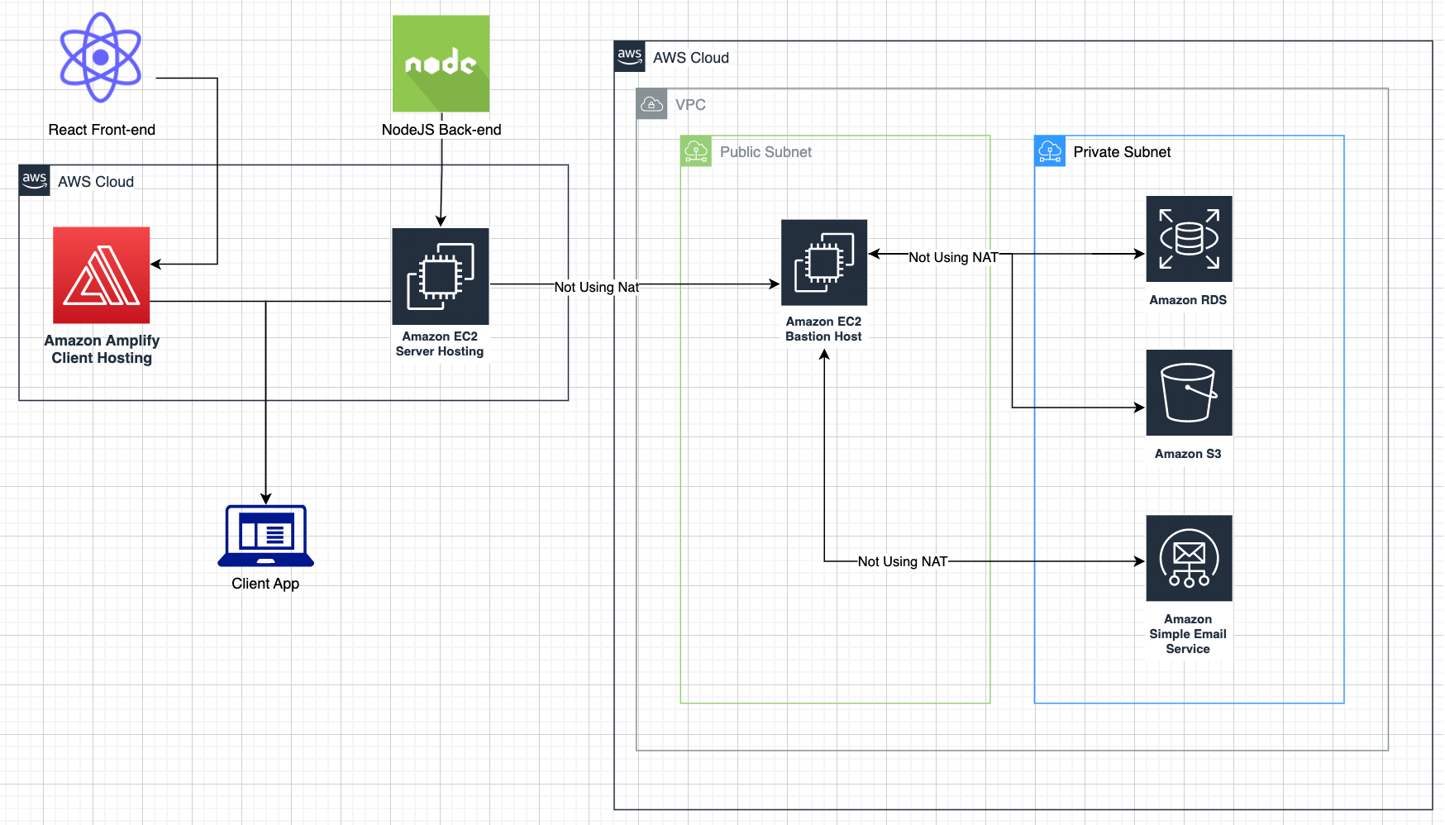

###### Figure 11: MedEire Architecture Design Using React, NodeJS and AWS services.

## 3.3. Software Methodology

Agile method anticipates the need for flexibility and efficiency in application delivery. agile focuses on the successful delivery of separate components or pieces of software instead of entire applications. Various teams use agile development methodologies by developing software iteratively and adding new features over time. This is done to reduce risk when adding new features such as bugs, cost overruns and changing requirements. [1]

Agile software method offers multiple advantages such as: [36]

* Adaptable, because the steps are small, it is extremely easy for the project to change direction or adapt to changing circumstances without destroying much of the earlier project.
* Quick problem detection, the testing phase allows you to quickly find any issues that arise. The fragmented nature of agile means that you can usually see where the problem is or what caused it, and then solve the issue in the next cycle of steps.
* Continuous improvement, this benefit is related to issue detection where improvements can be made at any stage of the application building process as it is easier to improve a single feature than to improve the entire application.

But if used incorrectly, agile could be detrimental to building projects because it also has drawbacks that need to be addressed to achieve successful development and those drawbacks are: [37]

* Short-term Planning, if there are no clear goals and guidelines for a potential product from the start, Agile helps create the expected product. For this reason, this approach is often accompanied by impromptu planning to allow quick reaction and adaptability to unexpected events. However, these traits make agile a disadvantage as there may not be enough time to plan confidently to respond well to real-time feedback, especially if the foundation is weak.
* Ease of Falling Off Track, Agile can easily lose consistency and drift away from the goal. Because the process requires little planning and recent changes can be made to meet changing customer needs. If the project does not have a solid strategy, strong vision, and great leadership, the entire project can easily go astray and as a result, teams cannot create applications with compatible components that meet predetermined requirements.

Since the project is still in its first stages of development it is easier to use the agile method as it allows the project to adapt easily if there are any issues that occur in its development. There is also the fact that MedEire does not have a large team working on it and most of the disadvantages can be easily mitigated by setting multiple achievable goals for each of the features designed.

The agile method has many advantages, including allowing continuous improvements which will allow early testing of the features developed and improve to develop a fully functional web application.

### 3.3.1 Other Methodologies Researched

#### 3.3.1.1 Waterfall Methodology

The waterfall method is a rigorous linear model consisting of sequential steps (requirements, design, implementation, validation, maintenance) aimed at different goals. With the waterfall method, each stage must be completed before the next stage begins. This waterfall approach has proven successful for many IT projects as they typically have fixed time and budget, and these do not change significantly over the course of the project. [38]

Waterfall method supplies many advantages toward project creation, some examples of these are: [39]

* Uses clear structure, waterfall focuses on a specific, defined set of steps with a simple structure and no steep learning curve.
* Decides the end goal early, waterfall sets the goal or outcome early in the project, and the team must stick to that commitment. This ensures that the team is aware of the big picture from the start and is less likely to get lost in the details as the project progresses.

Even though waterfall is extremely easy to use and has many good traits its disadvantages must be acknowledged to make a rational decision in which methodology to use: [40]

* Makes changes difficult, projects with specific and rigid assumptions require a lot of work, and a sudden change in project parameters can disrupt the entire schedule, rendering much of the work done unnecessary.
* Delays testing, it’s risky to delay the testing phase until the last half of the project, but Waterfall requires the team to wait until phase four to assess the product. the project may have taken a long time to complete, so major changes may cause significant delays.

The main reason MedEire rejected waterfall was because the project is in its first stages, and it is preferable for the application to remain open to various changes and tests at this point rather than having to postpone testing for the last stages. The decision to not use waterfall method was not an easy one because this method is the simplest and one of the best if employed correctly but if not, it could damage the application heavily by not listening to feedback.

#### 3.3.1.2 RAD Methodology

Rapid Application Development (RAD) aims to produce applications quickly without compromising quality. RAD focuses on creating prototypes that adhere to detailed specifications and evaluating them until the client is happy with the outcome, this is repeated several times and these prototype testing supply useful data that reduces several risks from the development. [41]

The RAD model offers some powerful advantages to the development process such as: [42]

* Less risks, code vulnerabilities are patched before final release, supplying an advanced risk management solution.
* Flexible, it supplies greater flexibility as developers can adapt to necessary changes and add new features during the build process.

The RAD model is a very flexible and customer-friendly method, but it has some drawbacks if you don't have a big team [43]

* Relies on collaboration, it needs a lot of collaboration and joint efforts from many people and departments. It can be confusing if it's not set up or running correctly.
* Complex, requires customer input at various stages, making the process more complex than other methods.

Since it would be challenging to find users who consistently have the time to evaluate the application each time a new feature or tool is added, MedEire does not employ RAD.

The fact that MedEire only has a small development team is another factor that would make developing the app more difficult. The choice was made not to apply the RAD method as a result.

## 

## 3.4. Overview of System

MedEire is designed to easily schedule appointments online by reducing the time spent on this manual process. MedEire's appointment scheduling feature improves process efficiency and makes life easier for both patients and medical staff during their daily duties.

Below (Figure 12) is a UML diagram of how a patient would use MedEire, which essentially requires users to log into an account to make an appointment, update or cancel an appointment, and view their medical records.

The decision to require login before creating an appointment is made in two ways: first, to reduce the number of fake appointments, as having a web app that requires manual deletion of these appointments would add to workload; and second, to enhance the application security, as all patient information is protected by multiple "locks."

###### Figure 12: Patient UML Diagram

A UML diagram of how medical staff would use MedEire is shown below (Figure 13). Like (Figure 2), users of MedEire must log in to an account to view, update or cancel their appointments as well as to upload or download medical records.

The main distinction between these two scenarios is that the medical staff has access to two extra tools that patients do not. The first of these is a live chat, which enables quick communication between staff members without the use of additional applications, and the second is a task manager, which enables staff members to create various tasks and assign them to other staff users.

Typically, medical staffs currently use multiple applications to complete all these tasks. However, having all the tools in one place would improve process productivity. So, it was decided to have separate tools for patients and staff to solve the problem for both patients and medical personnel with only one application.

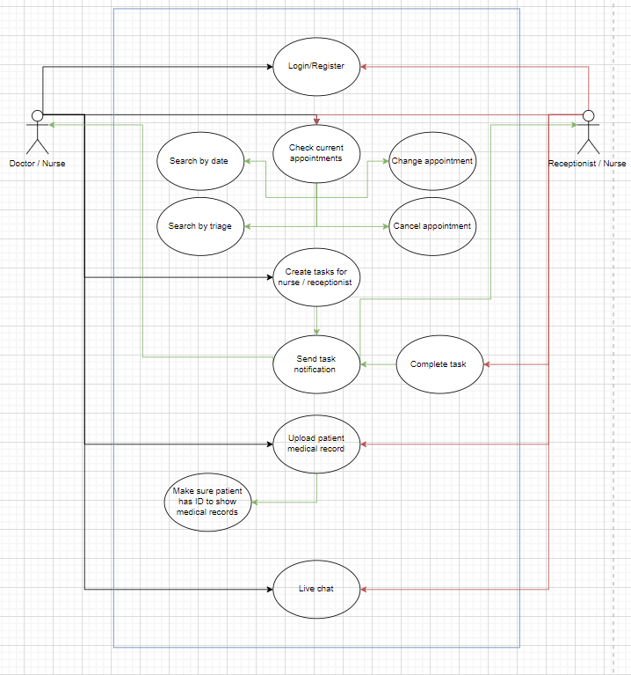

###### Figure 13: Doctor, Nurse, and Receptionist UML Diagram

### 3.4.1 Patient usage scenario:

The patient first registers an account in MedEire. After the patient has created their account or login,

They are then able to schedule their appointments by searching available dates or by searching the availability of a specific doctor.

The appointment creation has the date and time, the triage, a brief description, and the doctor’s name which is not required.

Once their appointment is scheduled, the user receives an email or phone notification confirming the details of their appointment.

On the website they are now able to manage their appointments, either changing the details mentioned above or cancelling the visit.

After their visit to the GP or nurse, if there was any medical report uploaded into the patient account by their doctor or nurse, the patient receives a notification to authenticate their account by uploading the consent form and two picture IDs to view or download their file, only if the account has not been verified yet.

To view the prototype interface for this usage scenario, please see the ‘Patient Side Screens’ section, where there are multiple mock-up screenshots of the workflow.

### 3.4.2 Doctor / Nurse / Secretary usage scenario:

In this scenario the ‘Doctor/Nurse’ actor (left actor) referred from now on as only the ‘doctor.’ Similarly, for the ‘Receptionist/Nurse’ actor (right actor) it will be referred as the receptionist from now on.

Doctor and receptionist both create their accounts in MedEire and once created they search the appointments by date or triage that were created by the patients. If necessary, they are also able to change the details (which are date and time, the triage, a short description, and the doctor’s name which is not required) of the patient appointment and or cancel the visit.

The doctor also has a task manager in which they can create different tasks for the receptionist to complete. Once sent, it delivers a notification to the receptionist and when it has been completed the receptionist is able to mark it as completed. The doctor is then able to check its completion by looking at the task manager or they receive a notification (either in their email or in MedEire)

Once the medical appointment has taken place the doctor is allowed to upload the medical records to the patient and the system sends a notification to the patient to check their account and upload their consent form and picture IDs if these are not already in the system.

Lastly, there is a live chat in which the doctor and the receptionist can communicate in case they need anything, such as sending the patients into the doctor office, asking the receptionist to create an extra appointment for the patient, requesting extra time with the current patient, etc.

To view the prototype interface for this usage scenario, please see the ‘Medical Side Screens’ section, where there are multiple mock-up screenshots of the workflow.

## 3.5. Conclusions

MedEire opted to use the proposed architecture because the use of Node.js as the back end and React for the front end is an approach that integrates greatly with AWS services. Also, these cloud services have been used in the development due to their affordability, scalability, and the large number of services that AWS provides.

Additionally, MedEire chose to employ the agile methodology as it is the most change-adaptive and enables the execution of numerous tests to ensure that the application has the proper approach, features, and behaviour.

Finally, the overview of the system shows that MedEire chose this approach of having distinct features for patients and staff because both users have problems that need to be solved differently. Instead of developing two separate web applications for each set of users, MedEire focuses on solving both problems in a single application.

# 4. Testing and Evaluation

## 4.1. Introduction

One of the main phases of this project is to ensure the functionality and quality of MedEire. The standards needed to be checked are specified on the quality assurance plan, it contains a user guide and questionnaire to assess MedEire efficiency for activities that must be conducted and ensure the application complies with the user’s standards.

## 4.2. Plan for Testing

When planning the evaluation, the following aspects will be considered: the location, time, available resources, and the population that will be required to carry it out.

MedEire is designed to be used by people over the age of 18 and by all genders, with a focus on the medical community and patients. It is intended to be evaluated in Ireland, however MedEire can be used anywhere.

Functionality tests will be conducted in Ireland by patients and medical staff, specifically at TUD Medical Centre by medical staff and patients over an estimated time of 4 weeks as it will be implemented in multiple phases.

## 4.3. Plan for Evaluation

The phases of this evaluation plan consist of a user guide and a questionnaire:

This user guide is designed with the purpose of verifying the proper use of each function of MedEire. The questionnaire is created with specific questions to assess each feature of the application.

* The user assessing the application must follow the manual evaluating the below features:
* Registration or create an account/ Login / Account Management.
* Create or Schedule, Re-Schedule, and Cancel or Delete Appointment.
* Notifications for Appointment Creation or Schedule
* Internal Live Chat.
* Task Manager.
* Upload and Download Medical Records.

### 4.3.1 Patient’s Manual:

#### 4.3.1.1 Registration / Login

Registration:

* To register patients must create and account and enter their, name, surname, email, PPS, and password, confirm the password, and click on create an account.
* User receives a confirmation email, click on confirmation email.
* Once confirmed, click on MedEire home page to login.

Login:

* To login user must enter email and password.

On the home screen, users can access a menu on the left-hand side to open the sidebar, where they can view and manage their current appointments, schedule new appointments, edit existing appointments, view medical records, manage their account settings, and log out.

#### 4.3.1.2 Account Management

Click on the account button located on the *sidebar*:

Account:

* Edit each the email, name, surname, password by clicking on the "Edit User" option, make the desired changes and click the "Update" button to save your changes.

Delete account:

* Click on the "Delete Account" option and confirm by clicking on the "Delete" *button.*

#### 4.3.1.3 Appointment Creation

To schedule an appointment, click on the "Schedule Appointment" button located on the home page or menu. User will be prompted to provide the following information:

* Choose DR’s name, preferred date and time, triage or reason for appointment and type brief description.
* Once user have entered all the necessary information and confirmed the appointment, user will receive an email confirmation.
* To view the current appointment details, click on the "Current Appointments" tab on the right-hand side of the menu bar.

#### 4.3.1.4 Edit / Delete Appointment

To edit or delete an appointment, click on the "Edit Appointment" button located on the home page or menu:

Edit Appointment:

* After updating the triage, doctor, date, or time information, the user can click on the "Update Appointment" button.
* Upon doing so, a confirmation message will appear at the top of the screen, notifying the user that the changes have been successfully made.
* Additionally, the user will receive a confirmation email to further ensure that the updates have been received and processed.

In case the user realizes that they do not want to change their appointment, they can click on the "Cancel" button. This will revert all the changes made and restore the original information and appointment details. This ensures that users can easily correct any mistakes or changes made by mistake without any hassle.

Delete Appointment:

* If the user wishes to delete their appointment, they can click on the "Delete Appointment" button. A notification message will appear, asking the user to confirm if they want to proceed with deleting the appointment or not.

In case the user decides not to delete the appointment, they can click on the "Cancel" button to revert the deletion process. This will ensure that the original information and appointment details are retained, and the user can continue to manage their appointments without any inconvenience.

#### 4.3.1.5 Medical Records:

To download medical records user must click on the "View " button in the file.

Once all these steps have been completed, fill in the monitoring and evaluation form to report any bug, feedback, or comment on this session.

<https://docs.google.com/forms/d/11rrKOPZllkTiLLU9PeNKx2RGjzEFi0hAfNYwkyBUFEI/edit>

### 4.3.2 Medical Staff Manual:

#### 4.3.2.1 Registration / Login

Medical staff receive a personal code to create their account for extra security.

Registration:

* To register or create an account user must enter their, Employee’s ID, name, surname, Employee’s email, and password, confirm the password, and click on create an account.
* User receives a confirmation email, click on confirmation email.
* Once confirm it, click on MedEire home page to login.

Login:

* To login user must enter employee email and password.
* On the home screen, users can access a menu on the left-hand side to open the sidebar, where they can view and manage their current appointments, schedule new appointments, edit existing appointments, view medical records, and upload medical records, Live chat and Task manager and log out. The task manager is not fully functional in the first phase.

#### 4.3.2.2 Account Management

This session will only be edited by the main administrator.

Delete account:

* This session will only be edited by the main administrator.

#### 4.3.2.3 Appointment Creation

To schedule an appointment, click on the "Schedule Appointment" button located on the home pageor menu. User will be prompted to provide the following information:

* Choose Patient PPS, DR’s name, Preferred date and time, triage or reason for appointment and type brief description.
* To view the current appointment details, click on the "Current Appointments" tab on the right-hand side of the menu bar.

#### 4.3.2.4 Edit / Delete Appointment

On the home page or menu, locate and click on the "Edit Appointment" button.

Find the appointment you want to edit or delete and click on it.

To edit the appointment details, update the triage, doctor, date, or time information as needed.

Once the user has made the changes, click on the "Update Appointment" button.

A confirmation message will appear at the top of the screen, notifying you that the changes have been successfully made.

If the user wants to change their appointment, click on the "Cancel" button.

This will revert all the changes made and restore the original information and appointment details.

Delete Appointment:

* If the user wishes to delete their appointment, they can click on the "Delete Appointment" button. A notification message will appear, asking the user to confirm if they want to proceed with deleting the appointment or not.
* In case the user decides not to delete the appointment, they can click on the "Cancel" button to revert the deletion process. This will ensure that the original information and appointment details are retained, and the user can continue to manage their appointments without any inconvenience.

#### 4.3.2.5 Medical Records:

User must click on Medical Records in the home page or menu to schedule Upload or Download *patient’s* files.

* User must enter patient name to view the patient medical records and upload any files into the patient account.

#### 4.3.2.6 Task Manager:

**Due to time constraints, the completion of this feature was not possible within the current phase of the App's development. However, it is planned to be included on next stages.**

User must click Task Manager in the home page or menu to check their current tasks or create tasks for other staff members.

* User creates a task by entering the title and description.
* Task can be moved into: ‘to do, in progress or completed.’
* User creates a task for other staff members by entering the staff name, title, and description.

#### 4.3.2.7 Internal Live Chat

User can access the chat in any of the screens by clicking on the chat rooms on the left side of the screen.

User can search other staff members and send messages to chat to them.

Once all these steps have been completed, fill in the monitoring and evaluation form to report any bug, feedback, or comment on this session.

<https://docs.google.com/forms/d/1J9-tRl_jx78uFG6WtSyArdpaw2HYHRvNx1YoMGtlGCg/edit>

## 4.4. Conclusions

In conclusion, the evaluation and verification process of the application has the purpose of making sure that it is implemented correctly and make sure the entire system works as expected. Testing helps uncover hard-to-predict scenarios and situations to that are difficult to find by just reading the application’s software.

Recording the data collected during the test is a mechanism used to implement improvements of multiple features or tools to the application as well as being able to analyse the development procedures and quality improvement.

# 5. MedEire Development

## 5.1. Introduction

The development of a prototype app is a crucial stage in the process of creating a successful and effective digital product. The MedEire prototype app is a significant milestone that involved meticulous attention to detail in terms of its features, and functionalities aspects.

The primary objective of this phase was to gather all the necessary data and insights to ensure that the final design of MedEire meets the expectations of its users.

The importance of a well-crafted prototype cannot be overstated, as it provides a tangible representation of the product's capabilities and allows for testing and refinement before the final product launch.

## 5.2. MedEire Development

The prototype development process helped to identify potential issues early on and refine the user experience to ensure the final product meets users' needs and expectations.

Through creating a prototype, the app's features and functionalities were tested and refined, making it more user-friendly, efficient, and effective.

Although there is still room for improvement in the design, the initial version of the application is functional, with most of its programmed features implemented.

However, due to time constraints, the task manager feature will be developed in the second phase. Additionally, the second phase will focus on improving the design to enhance the overall user experience.

On the Login page, users must enter their email and password to gain access to their account. Once the information is verified, they are redirected to the home page (Figure 14).

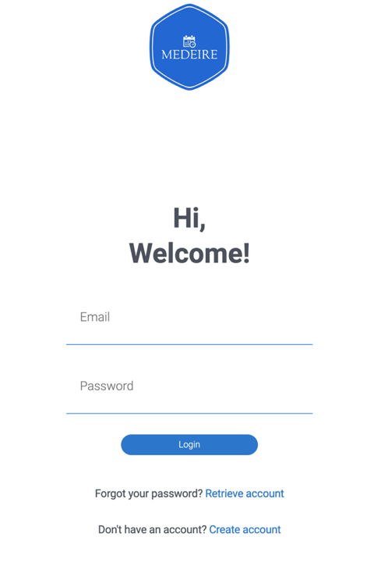

###### Figure 14: MedEire’s Login Page

Create an account or Register (Figure 15), once the user registers, an email is sent to the user to confirm the registration (authentication), once registered they can login into their account.

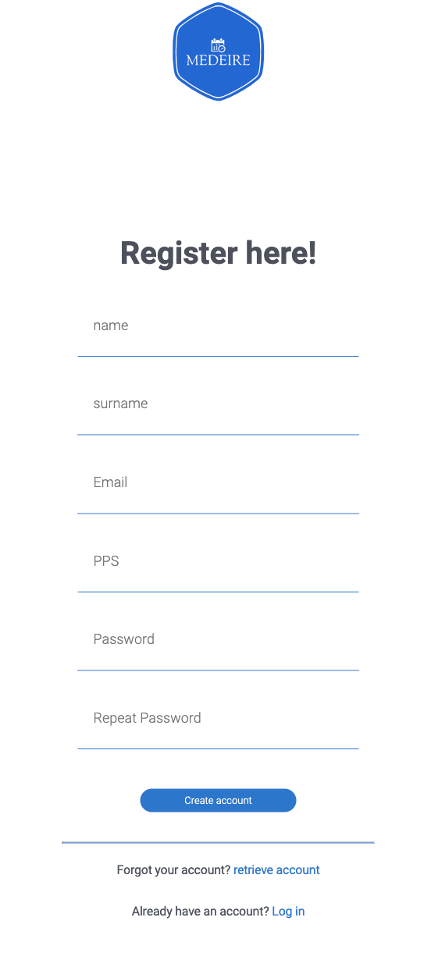

###### Figure 15: MedEire’s Registration Page

### 5.2.1 Patient Role Screens

The following descriptions and figures are intended for the patient side only. Once the user clicks on the 'Login' button, they will be directed to a bar side that features menu and account buttons.

(Figure 16).

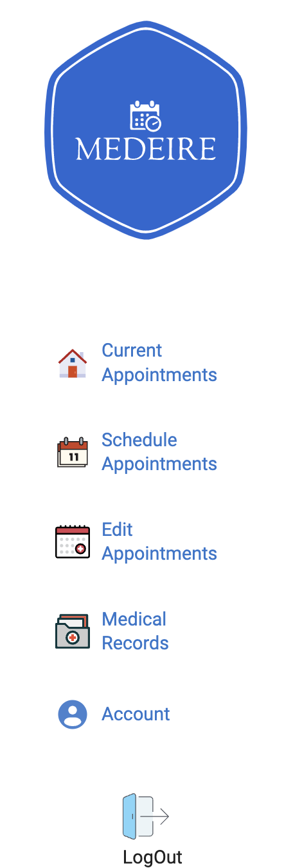

###### Figure 16: MedEire’s Patient Sidebar Menu

If the account button is clicked it will send the user to the Account Management page which allows the user to edit their email, surname.

The user can then press the update button to go back to the home page or delete their account which brings the user to the login page (Figure 17)

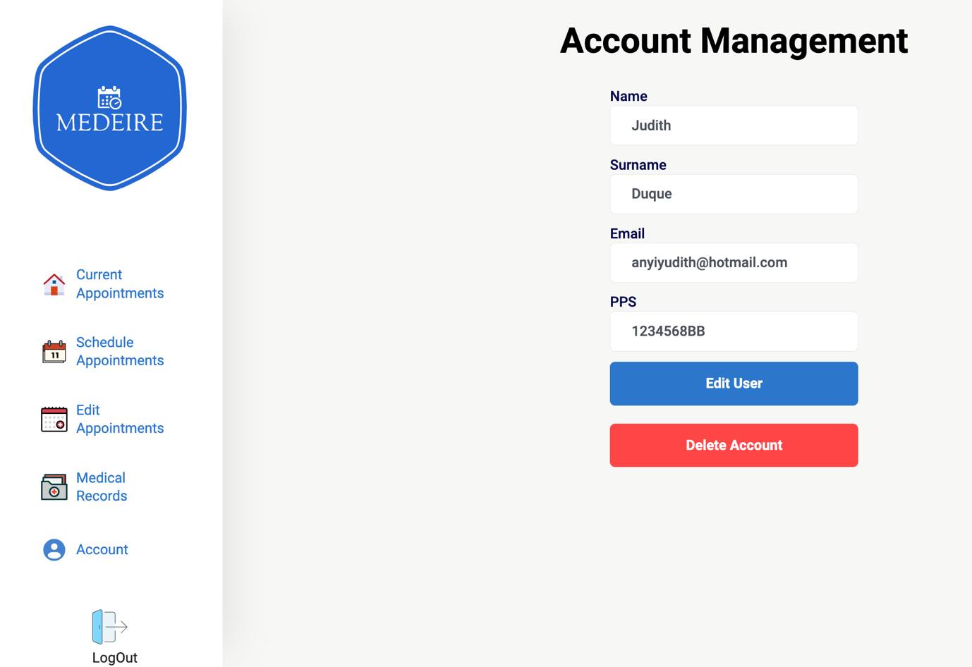

###### Figure 17: MedEire Patient Account Management Page

On the home page clicking Appointment, Update Appointment and Medical Record will send the user to the appropriate page (Figure 18)

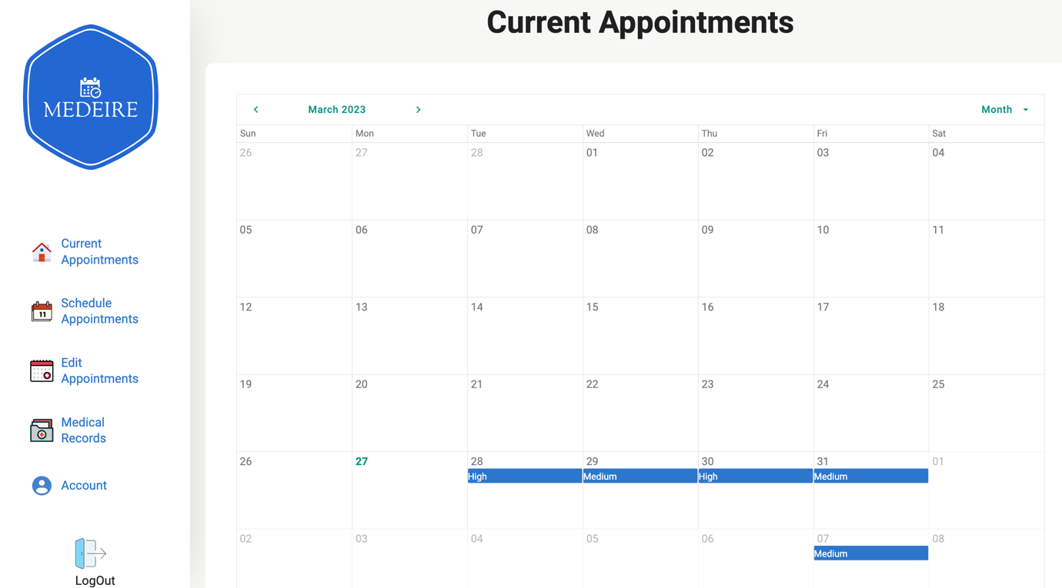

###### Figure 18: MedEire Patient Home Page

The appointment page lets the patient create an appointment by choosing triage, doctor, date & time, entering a brief description. Once the user is ready to continue, the schedule button brings the user back to the home page (Figure 19).

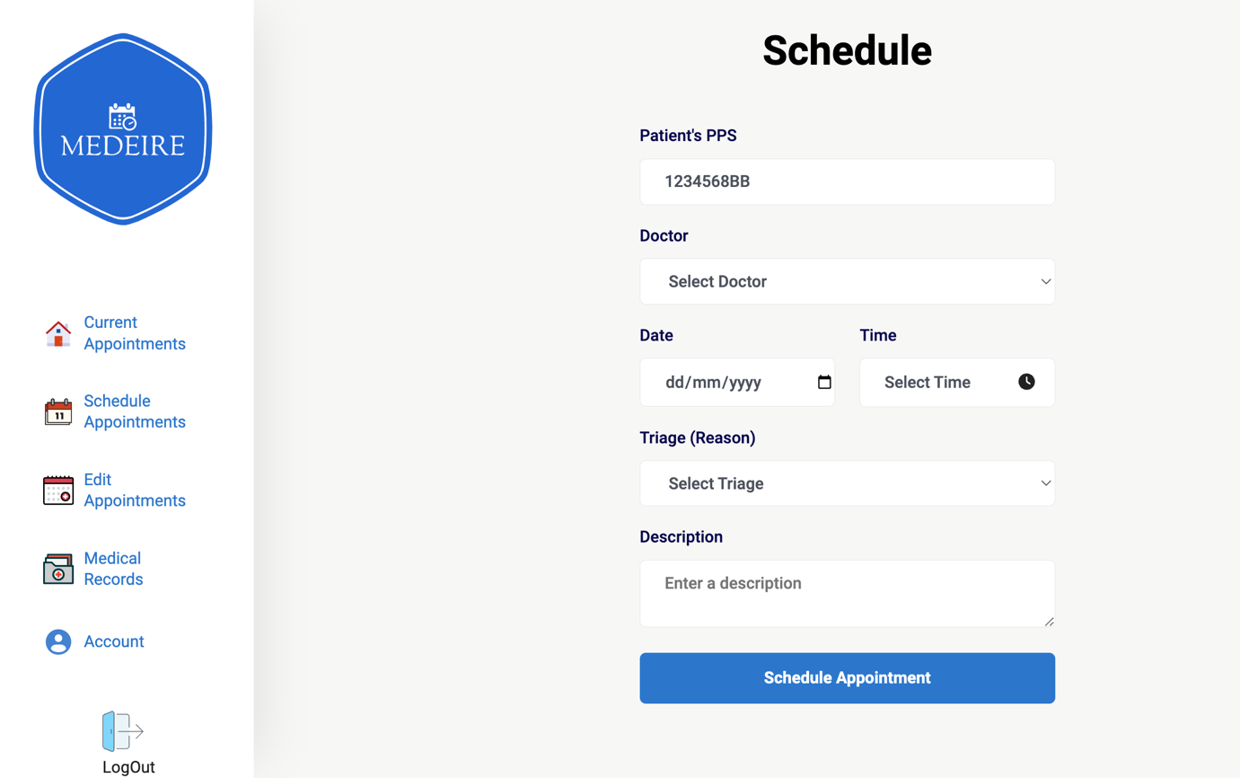

###### Figure 19: MedEire Patient Appointment Page

The edit appointments page allows the patient to change their current appointment by selecting it and then changing, doctor, date & time, its triage, and brief description, after the user is finished updating these, update and cancel buttons appear which will bring the user back to the home page (Figure 20).

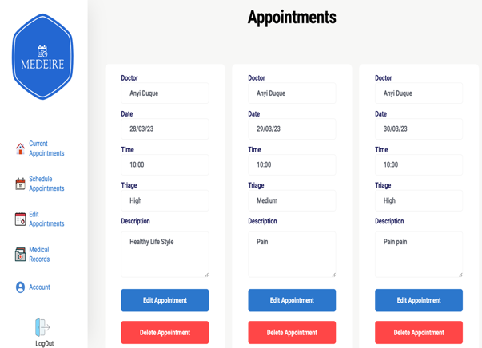

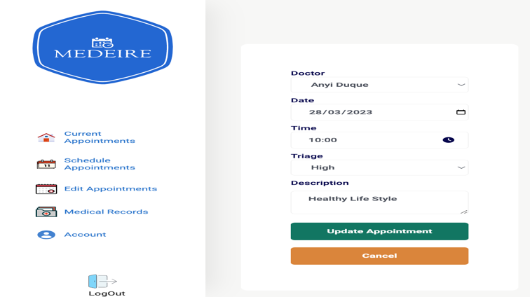

###### Figure 20: MedEire Patient Update Appointment Page

Lastly for the patient side there is the medical records page. By clicking on view, this page allows the user to download their medical record file. (Figure 21).

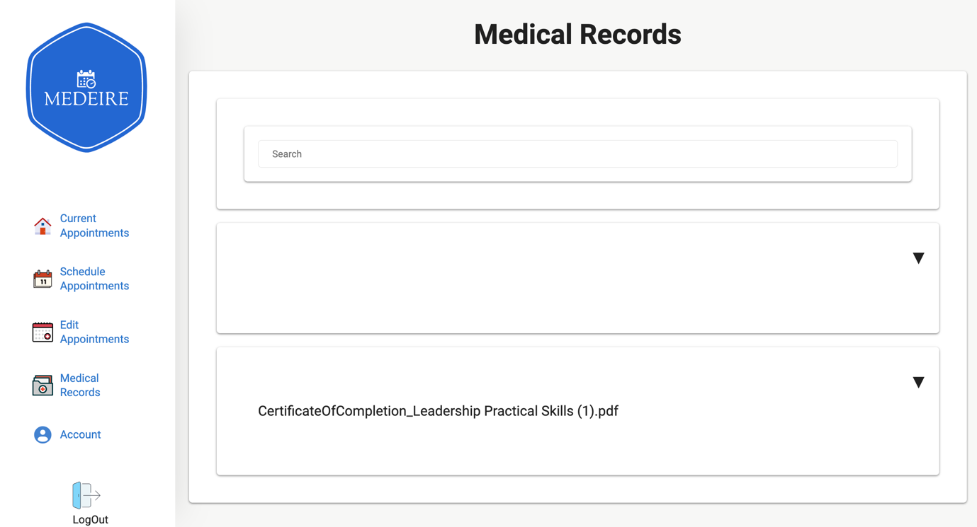

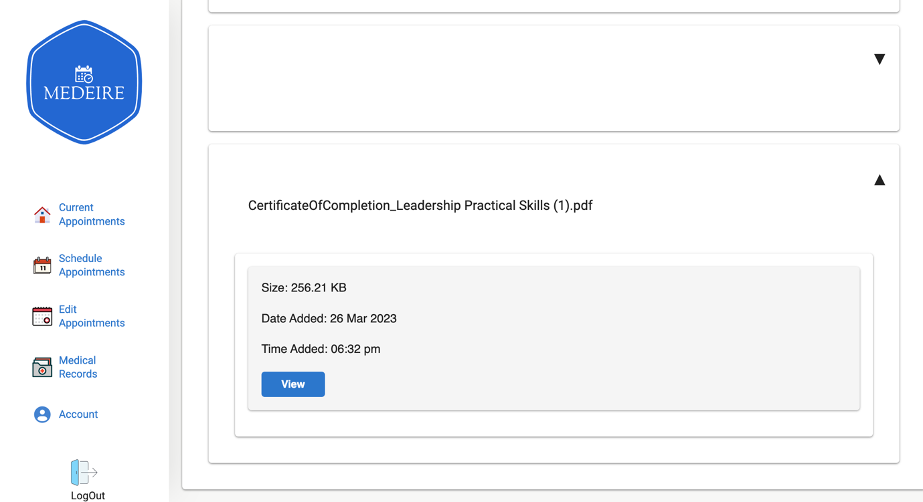

###### Figure 21: MedEire Patient Medical Records Page

### 5.2.2 Medical Role Screens

The below descriptions and figures are for the medical side only:

The medical side also contains the same side bar which contains the menu and account buttons but adds extra features. (Figure 22).

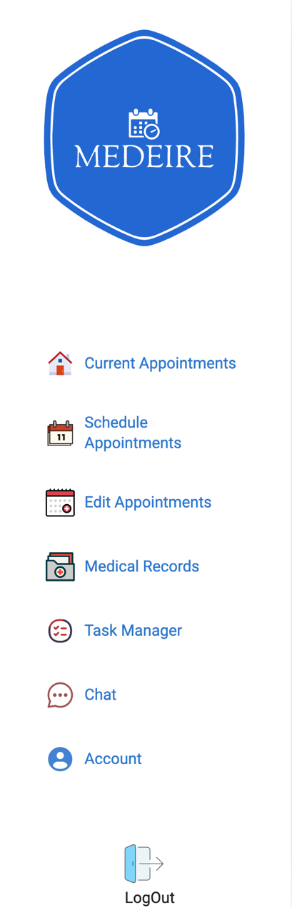

###### Figure 22: MedEire staff Sidebar

If the account button is clicked it sends the user to account details, which in this case any edition is allow only for the main admin user. (Figure 23).

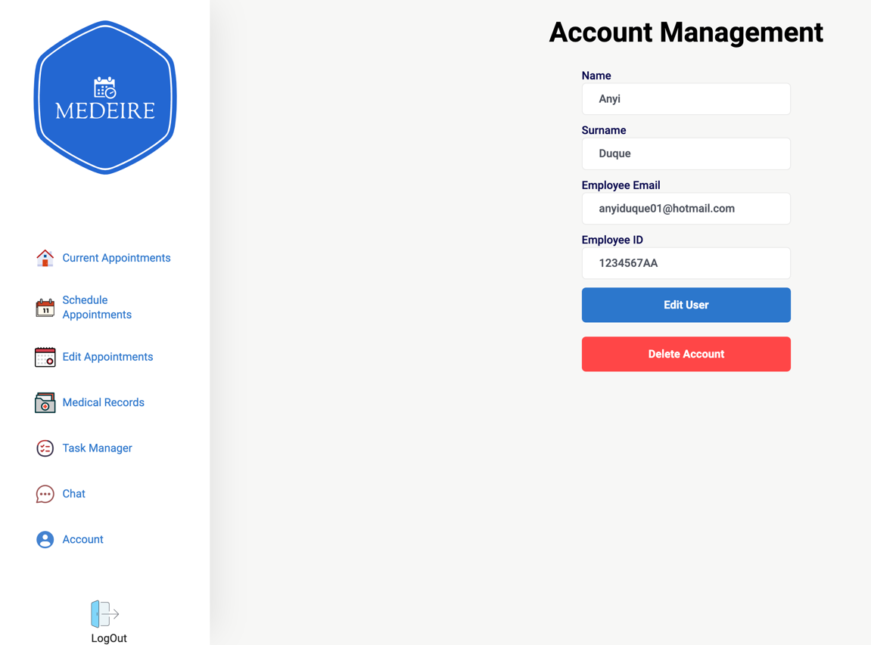

###### Figure 23: MedEire Staff Account Page

On the home page clicking ‘Current Appointments’, will send the user to the appropriate page, it allows the user to view their current appointments and click on it for more details, if the appointment is clicked it displays extra information (Figure 24).

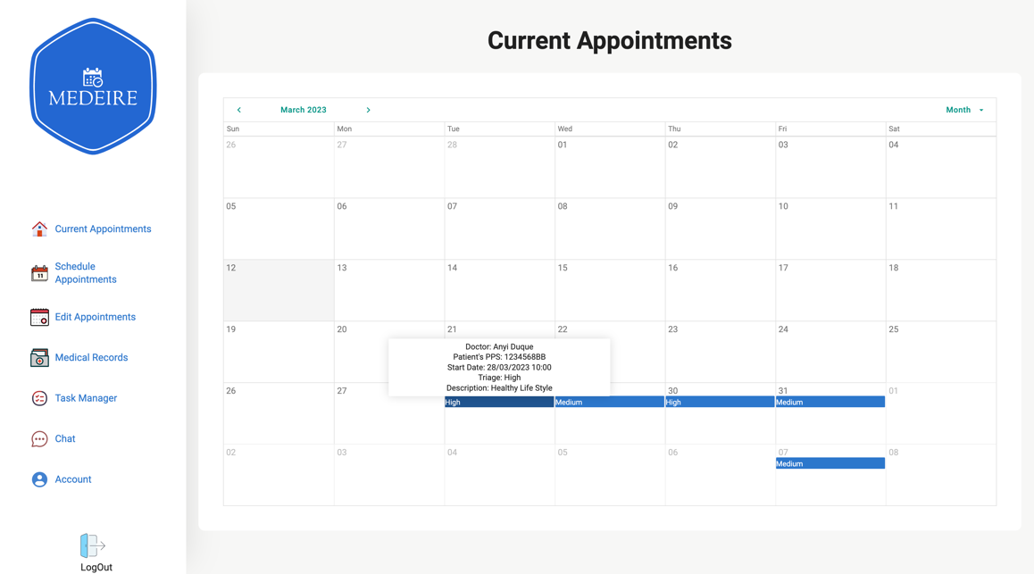

###### Figure 24: MedEire Staff Home Page

The live chat displays all the available staff members that the user can chat with (Figure 25).

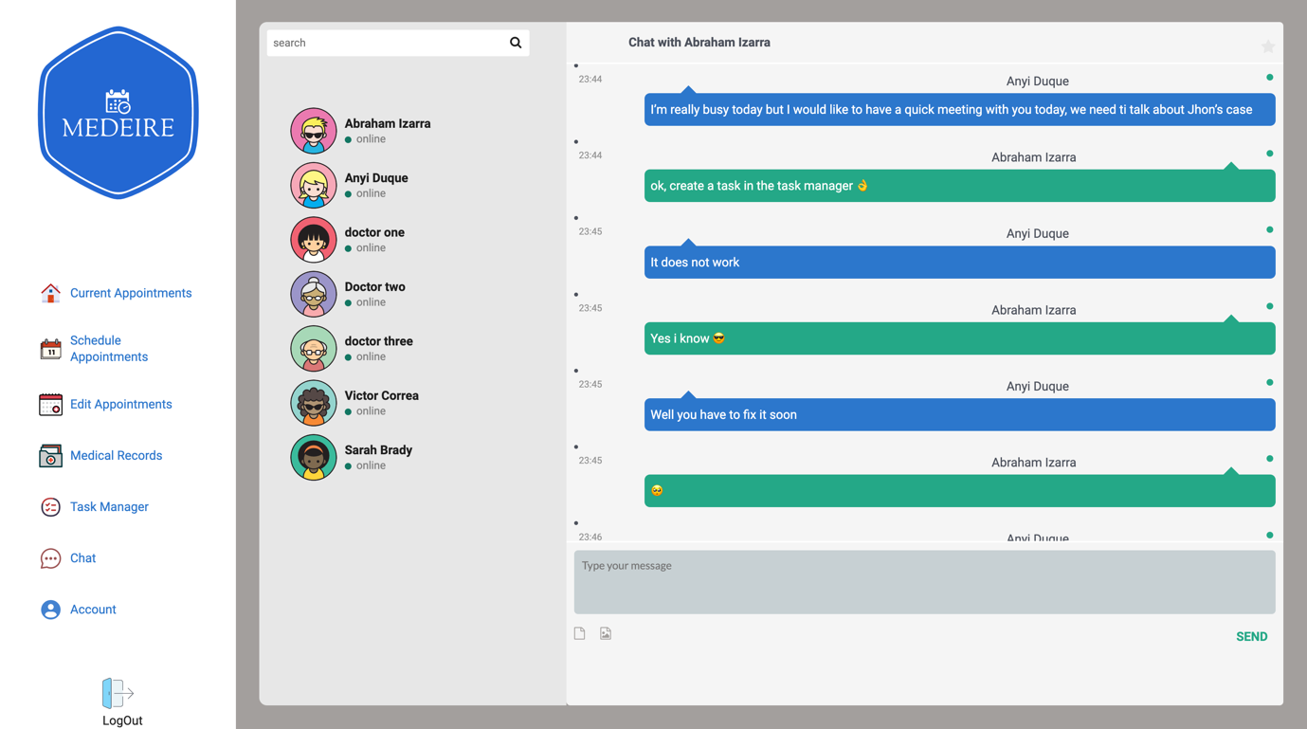

###### Figure 25: MedEire Staff Live Chat Page

The appointment page allows medical personnel to create an appointment by selecting patient PPS, triage, doctor, date & time, a brief description, and the schedule button (Figure 26).

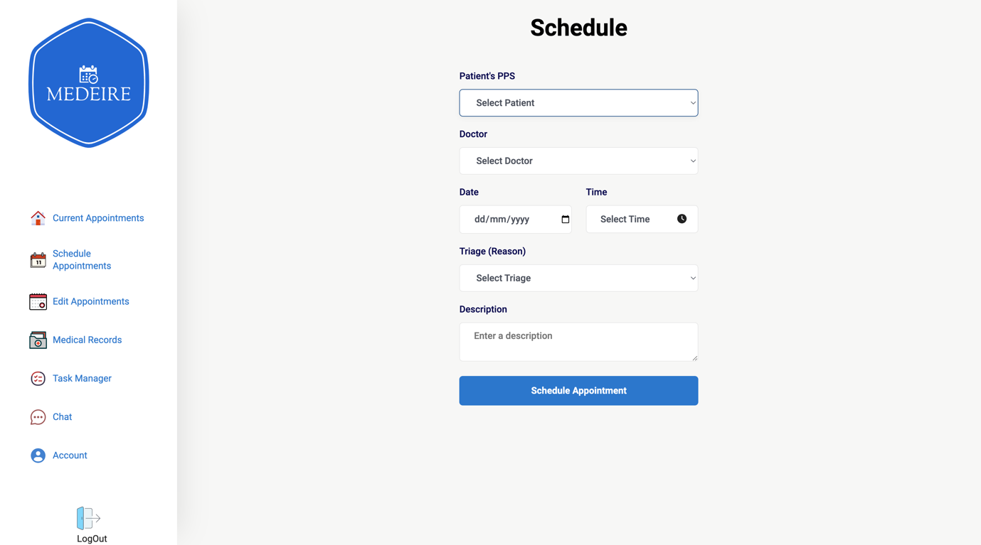

###### Figure 26: MedEire Staff Appointment Page

The update appointment page allows medical personnel to manage their current appointments by selecting it and then changing its triage, doctor, date & time, description. When ‘Edit Appointment’ is clicked the update and cancel (to cancel editing) buttons appear.

If the staff member clicks delete it delete and cancel (to cancel deletion) button appear (Figure 27).

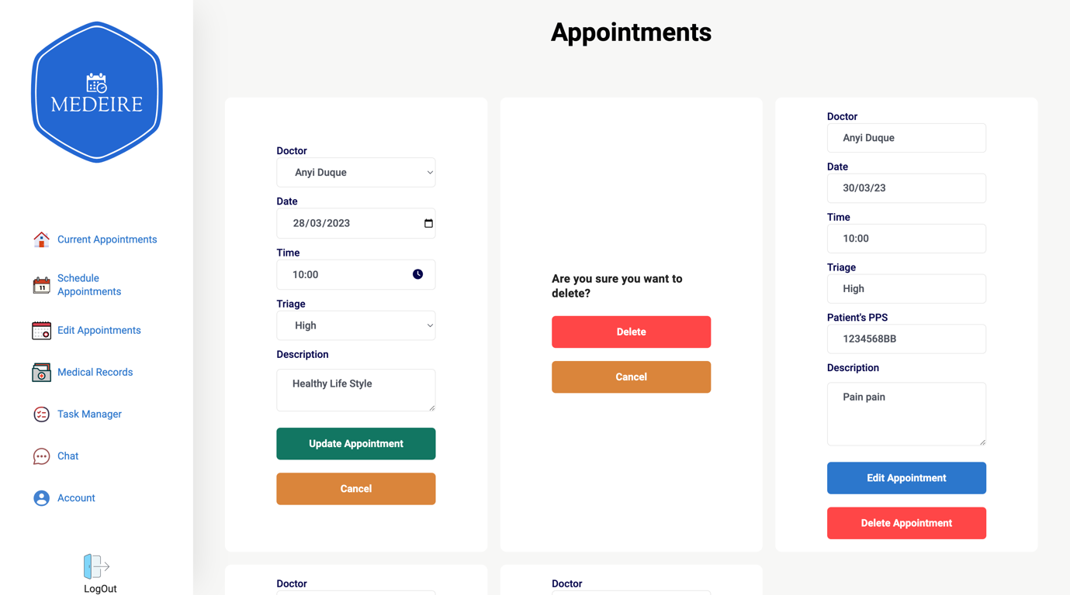

###### Figure 27: MedEire Prototype’s Staff Update Appointment Page

The medical records page allows medical personnel to search for a patient by name or file name and view their records and if needed upload the patient medical records into the patient account.

(Figure 28).

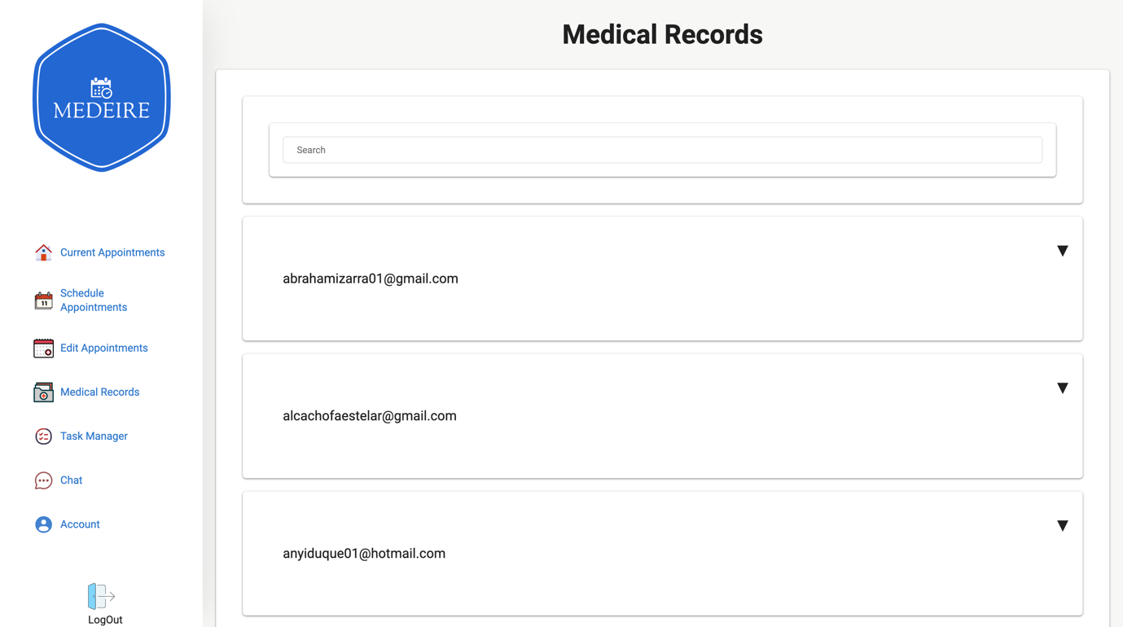

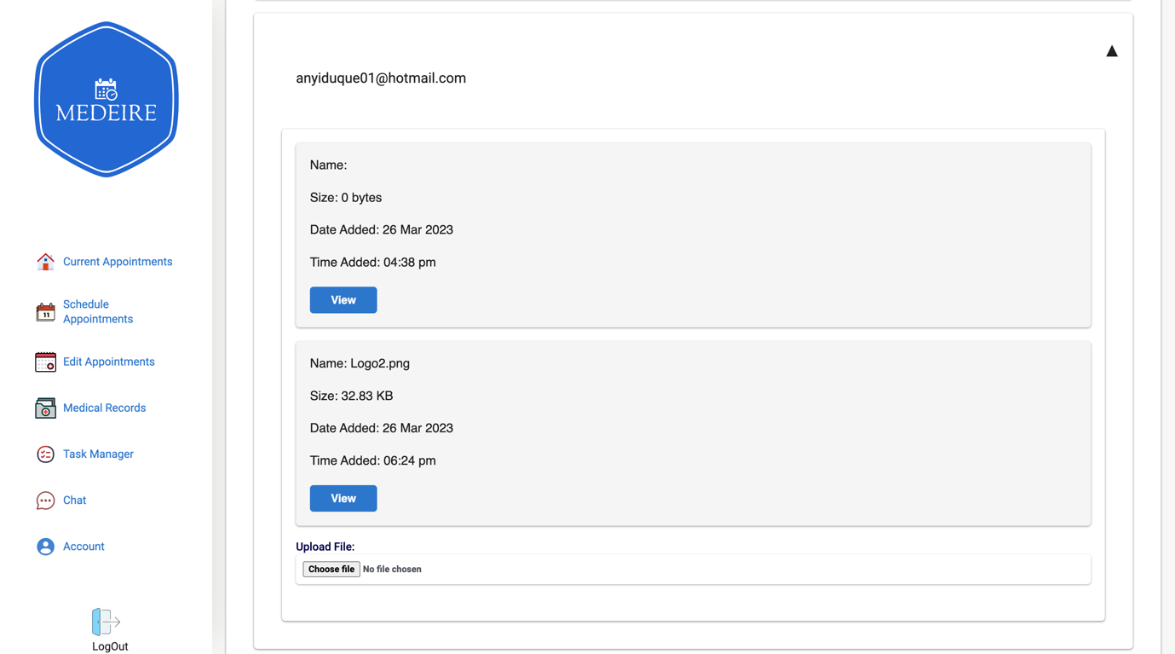

###### Figure 28: MedEire Staff Side ‘Medical Records’ Page

The task manager page, **Due to time constraints, the completion of this feature was not possible within the current phase of the App's development. However, it is planned to be included on the next stage.**  (Figure 29).

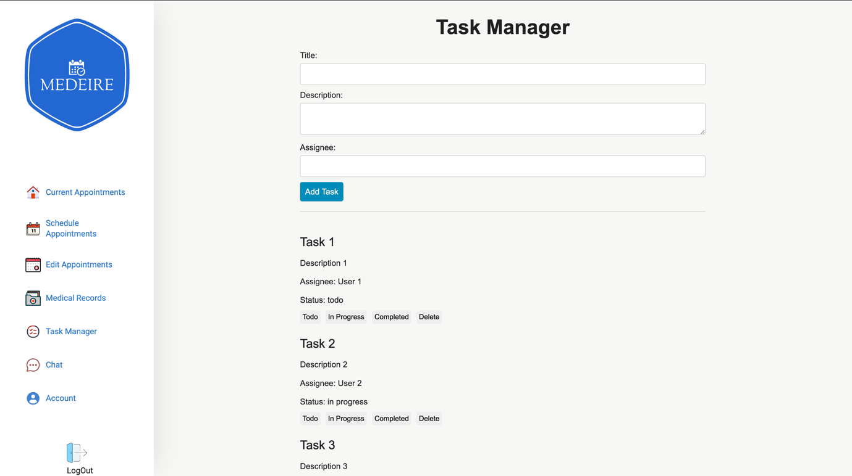

###### Figure 29: MedEire Staff Task Manager Page

### 5.2.3 Admin Role Screens

This page allows IT management to add or remove roles to any user, all the other pages for this user is the same as the ones for ‘user’ role.

For example: they cannot access other user’s medical records, they can only schedule appointments for themselves, etc.

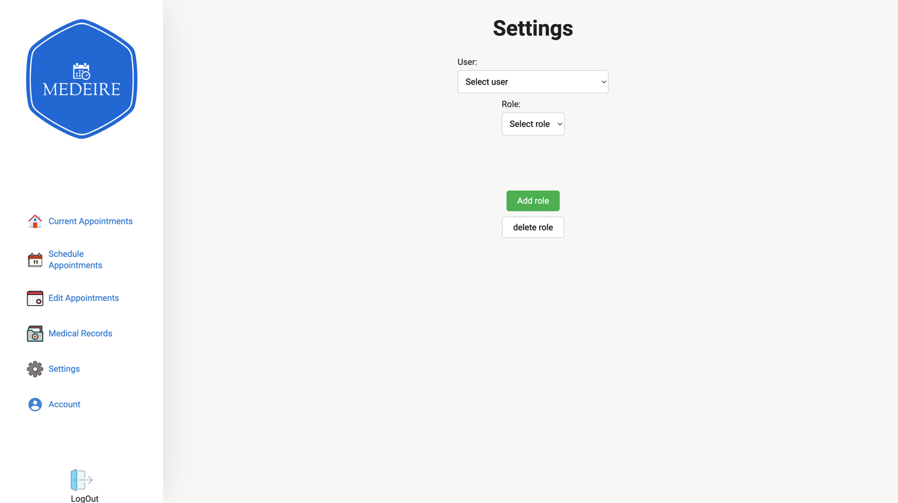

###### Figure 30: MedEire Admin Settings Page

## 5.3 MedEire Code:

### 5.3.1 Login

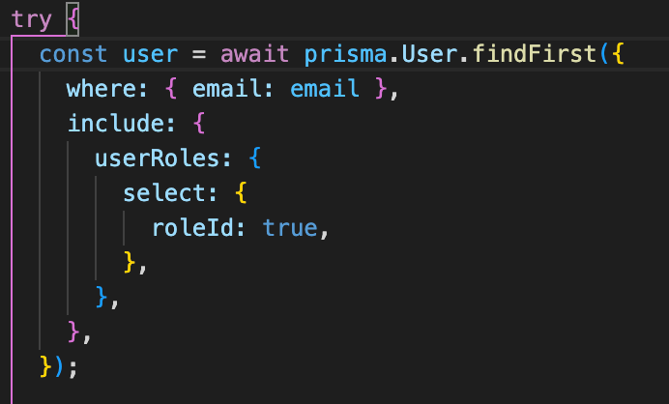

MedEire code utilizes Prisma ORM for interfacing with the MySQL database. The screenshot presented beside serves to exemplify the implementation of login functionality, where user data is retrieved by querying the database using email as the search parameter.

It also confirms that the hashed password is correct.

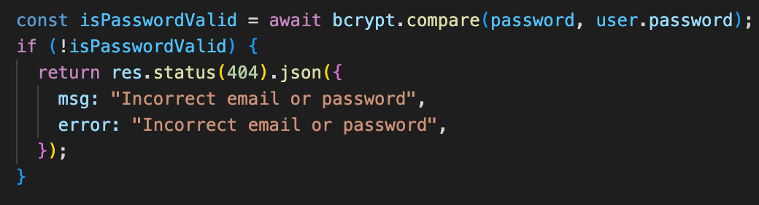

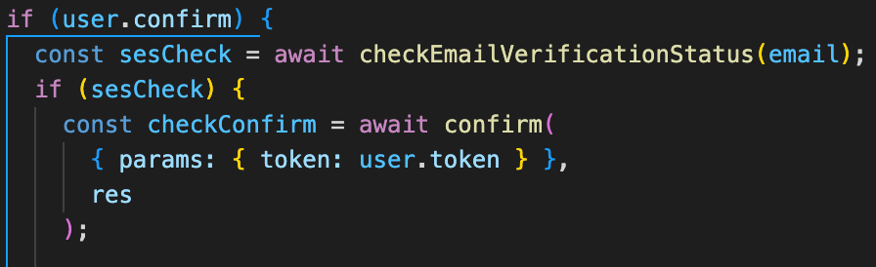

The verification process for confirming a user's account involves a check to determine whether the user has clicked the link provided in the confirmation email. This process entails querying Amazon SES to retrieve the verification status of the user.

Upon successful verification of the user's confirmation status, a folder is created in Amazon S3, along with a corresponding user and user policy. Subsequently, the user data is returned, thereby enabling the user to log in.

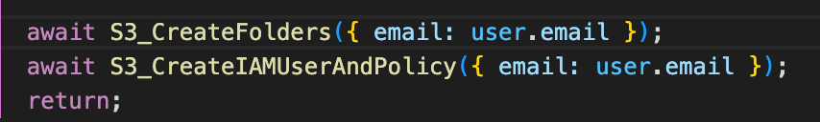

###### Figure 31 MedEire Login and Authentication Code

### 5.3.2 Registration

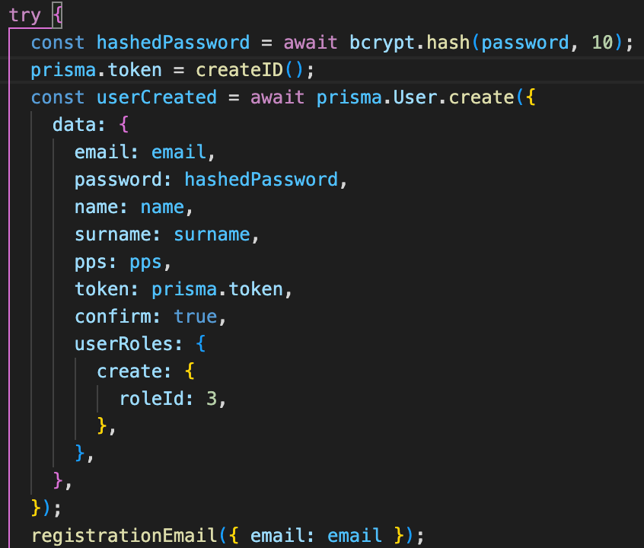

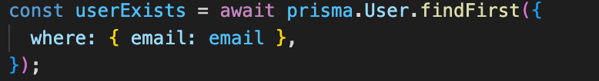

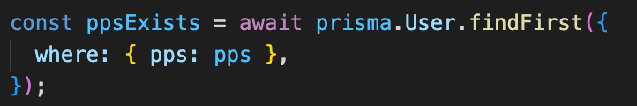

During registration, the system first verifies the absence of a pre-existing user account with the same email or PPS. If there is no such match, the system proceeds to create the user account.

The registration process involves several steps, including hashing the user's password, adding the user's data to the system, and sending a registration email using SES. This email serves as a means for users to authenticate their accounts and gain access to the system.

###### Figure 32: MedEire Registration Email Code

### 5.3.3 Navbar

The navbar is categorized based on user roles, with each role featuring distinct tools and functionalities that supplement those available to the "user / 3" role, which serves as the basic level.

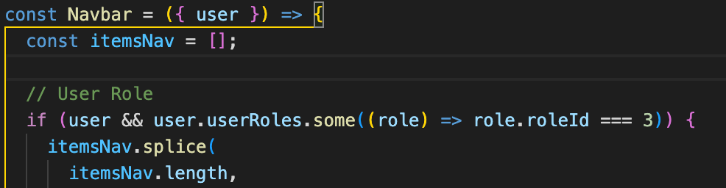

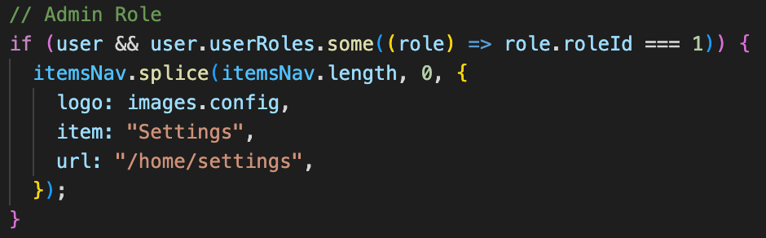

###### Figure 33: MedEire Navbar Menu Code

### 5.3.4 Account Management

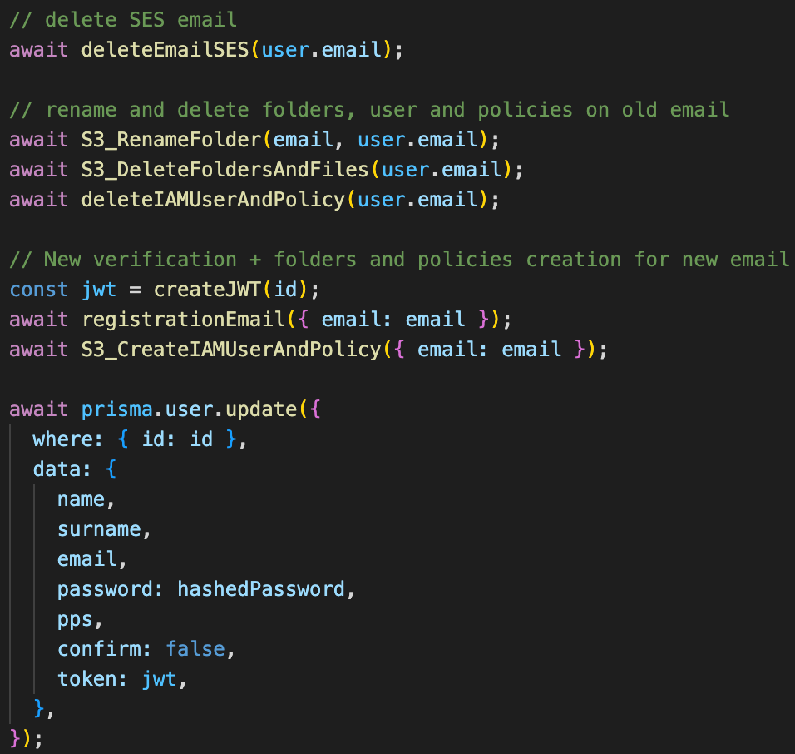

In the event of an email change, the system performs several actions. It first deletes the old email from SES, thereby removing the associated verification. Next, the system copies the old folder and files to a new folder in S3, deletes the previous folder and files, and removes the associated IAM user and policies. The system then generates a new token for the user, sends a registration email to the new email to initiate the verification process, creates new IAM user and policies using the new email, and updates the database by adding the confirmation token and setting the "confirm" field to false.

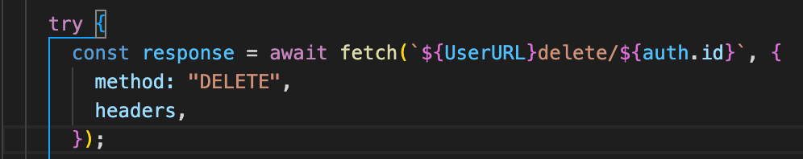

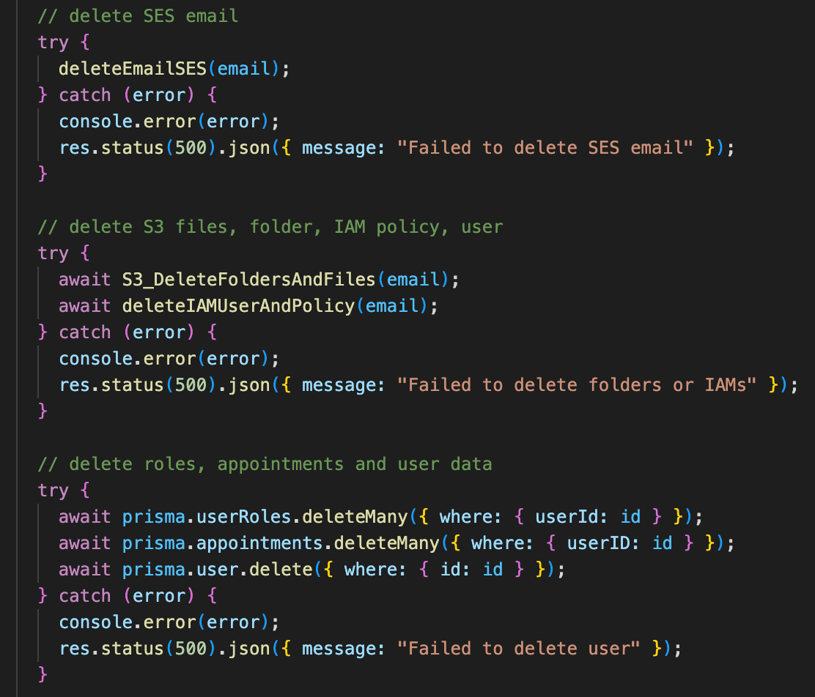

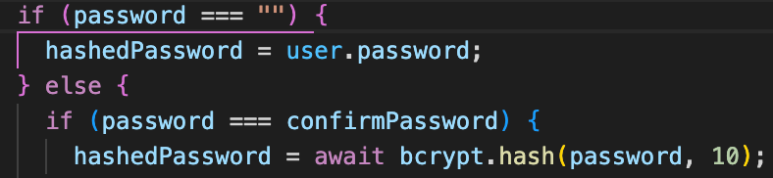

Initially, the system checks whether the user has left the password field empty. If this is the case, the system retains the previously stored password for the user.

Like changing email addresses, when a user deletes their account, MedEire utilizes an API endpoint to delete all associated data. This includes the user's data, S3 folders and files, IAM User and Policies, roles, appointments, and the user account itself. This ensures that all user data is completely erased from the system, promoting privacy and security. By implementing this process, MedEire can provide users with a reliable and secure account deletion experience.

###### Figure 34: MedEire Account Management Code

### 5.3.5 Home

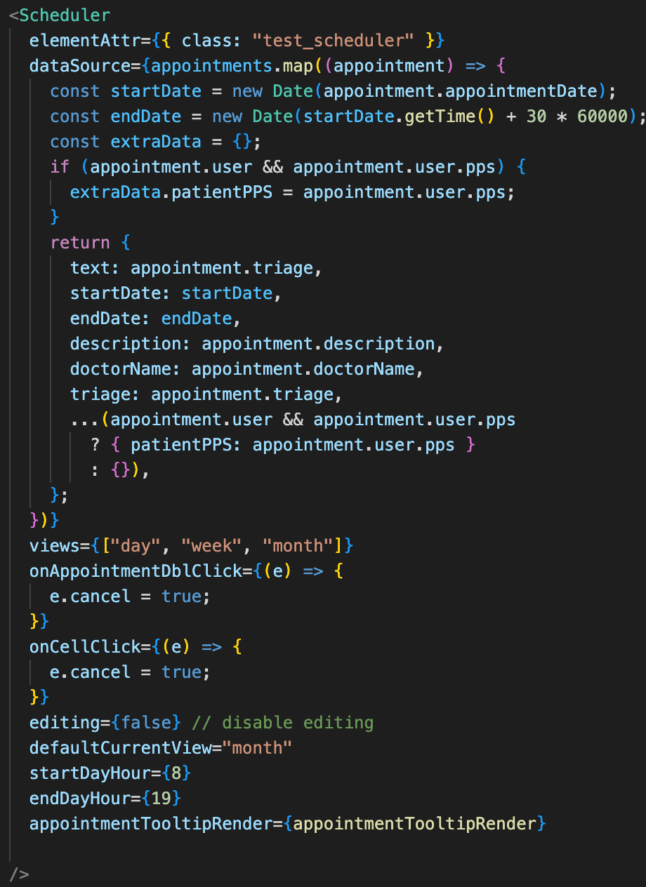

Upon accessing the home page, the API endpoint for appointments is utilized to fetch data from the database. This information is then assessed to determine if the user is either a doctor or a patient, and relevant information is subsequently provided based on their role. The Scheduler component from "devextreme-react" is utilized to receive and set the retrieved data.

###### Figure 35: MedEire Home Code

### 5.3.6 Appointment Creation

MedEire checks the user's role to determine their access level. If the user has a doctor role, all users' PPS names are displayed to facilitate appointment scheduling. However, if the user has a patient role, the PPS option is disabled on the form, and the user's PPS is automatically set. The code then utilizes API endpoints to locate all appointments and remove unavailable times from the list. It also retrieves all doctors to populate the form field. This ensures that appointment scheduling is effortless and efficient for all users of the system.

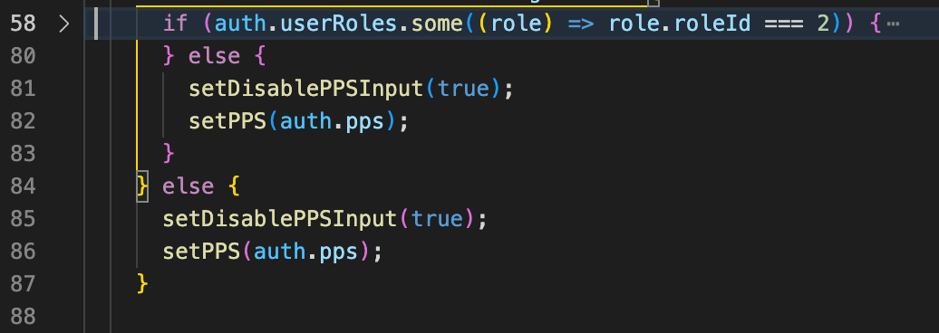

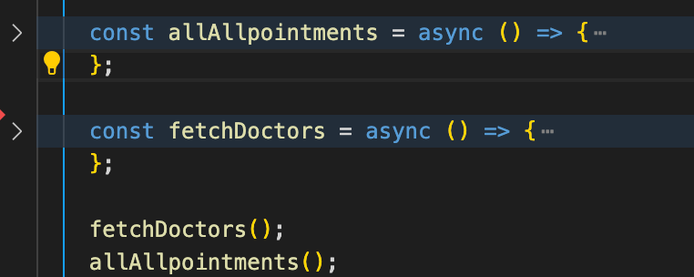

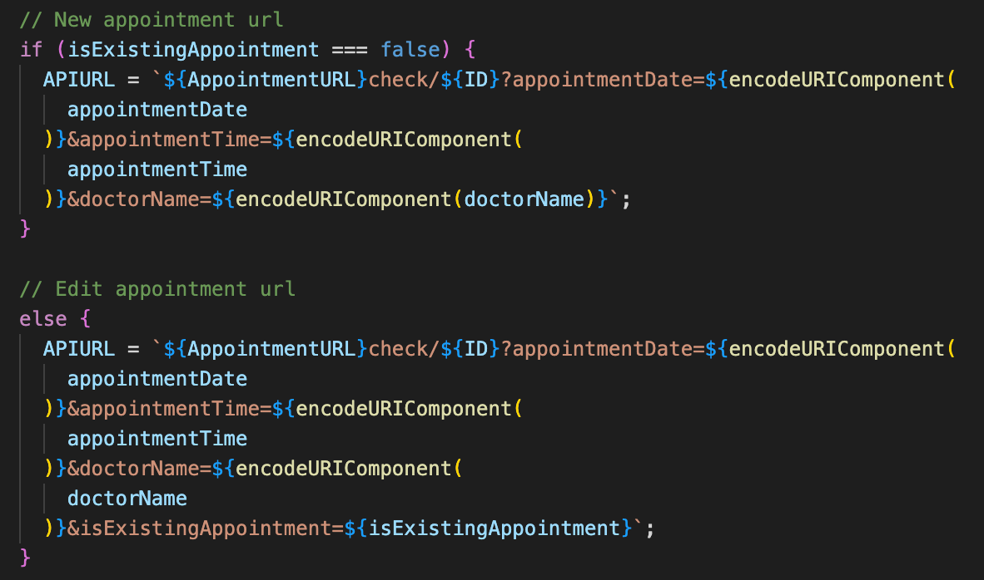

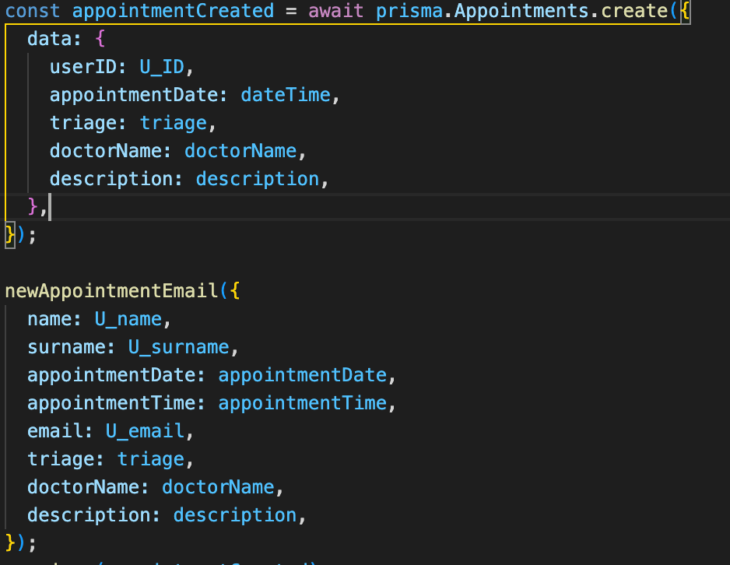

When a user submits an appointment form, MedEire runs several checks to ensure availability. Firstly, it verifies that the selected date/time is not in the past. It also checks the availability of both the doctor and user. Once all these checks are passed, the code creates the appointment on the database using API endpoints. Finally, MedEire sends an email confirmation to the user to confirm the appointment.

###### Figure 36: MedEire Appointment Creation Code

### 5.3.6 Appointment Management

The code obtains appointment data from an API endpoint and dynamically adjusts the 'Select PPS' functionality to a dropdown list with usernames if the user is a doctor. This data is then used to set appointment details, user roles, and available time options.

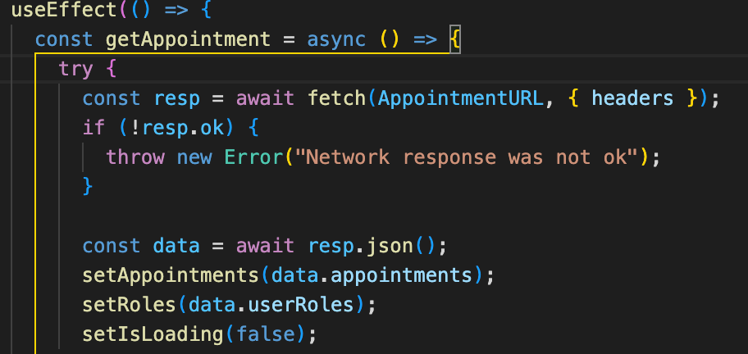

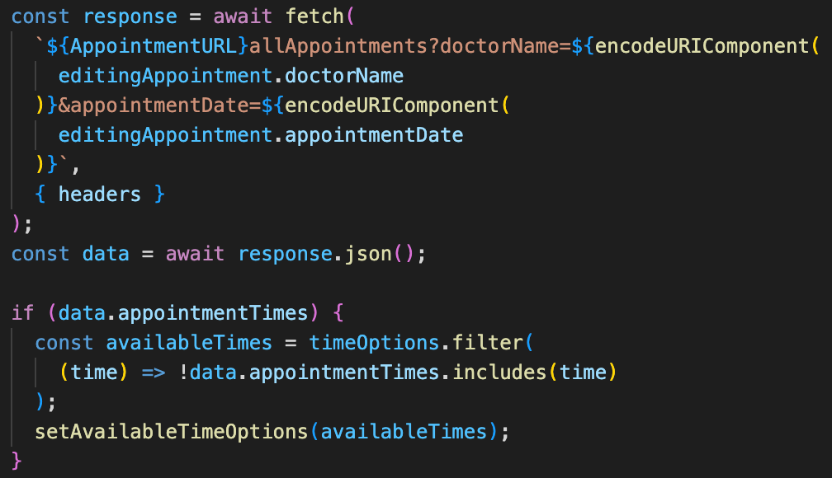

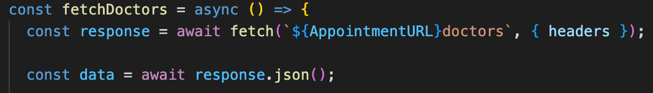

In addition, the code has a function that suggests available dates and times for creating new appointments, as well as a feature that checks for conflicts with overlapping appointments, avoiding scheduling errors. Moreover, the code automatically sends email confirmations with appointment details upon their creation. Finally, the code includes a feature that enables users to cancel appointments their appointments, ensuring efficient appointment management.

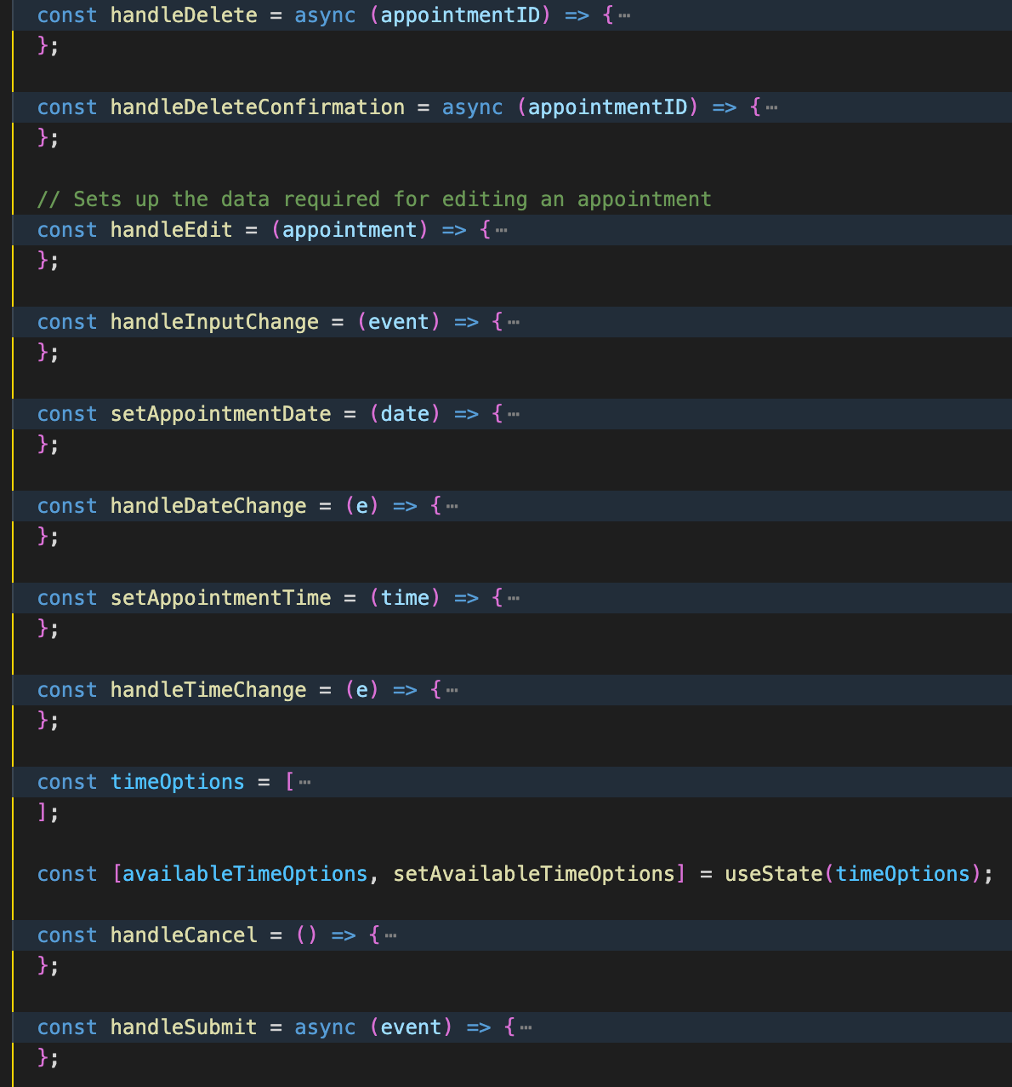

###### Figure 37: MedEire Patient Manage Appointment Code

### 5.3.7 Medical Records

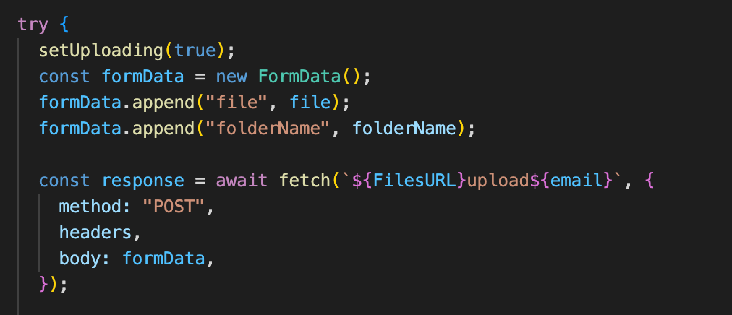

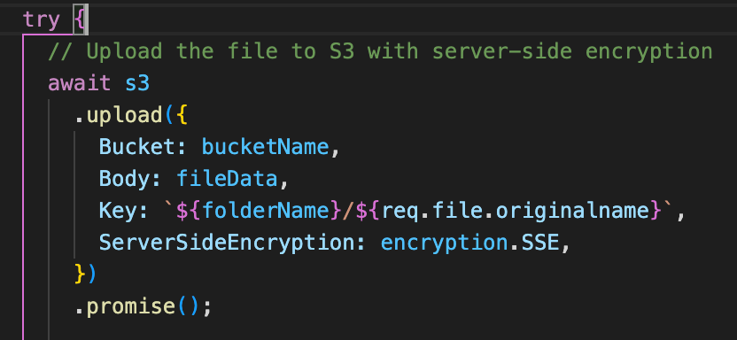

When the user's role is identified as a doctor, the page adds an upload button that enables doctors to upload files to any patient. This is accomplished by identifying the selected folder name and uploading the file to the S3 bucket, where it is saved to the folder that corresponds to the patient's email. The code ensures that only authorized users can access and modify patient data, thereby maintaining data security and privacy.

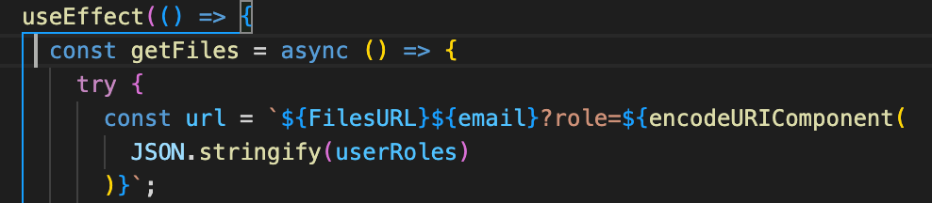

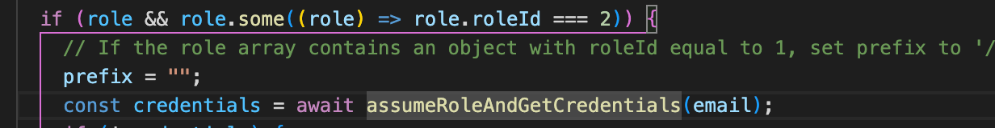

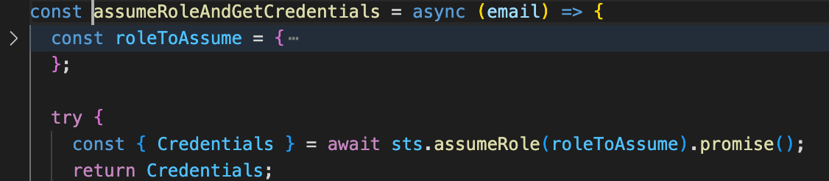

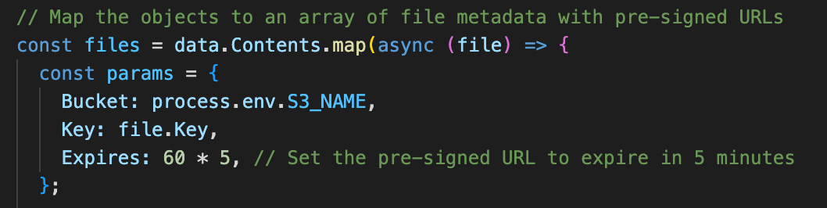

The code first finds the role of the user using an API endpoint that checks data stored on the S3 bucket and returns files depending on user role.

if the user role is doctor it uses Amazon STS to assume the doctor role (which allow uploading and viewing all files on the S3).

displays all the patient’s folders with their files and allow the doctor user to upload files into the patient’s folder.

If the user role is patient, then it only displays their own files (without folder)

Once data has being fetch it filter folders and maps them for a simpler design

###### 

###### Figure 38: MedEire Medical Records Code

### 5.3.8 Live Chat

MedEire first retrieves all staff members with the doctor role via an API endpoint and creates a list of available users to chat with. Once a user selects a staff member to communicate with, the system joins them to a new 'room' where they can exchange real-time messages.

The system uses Socket.io to listen to incoming messages and sends them to the selected room, while also storing them in the database using an API endpoint.

If the room has no message history, the database creates a new room to store all messages sent within it.

Socket.io also retrieves previous messages from the database and sets them in the frontend, utilizing a backend function to retrieve chats by their ID and filter them based on sender or receiver.

This ensures that all staff members can communicate effectively and efficiently, promoting seamless collaboration.

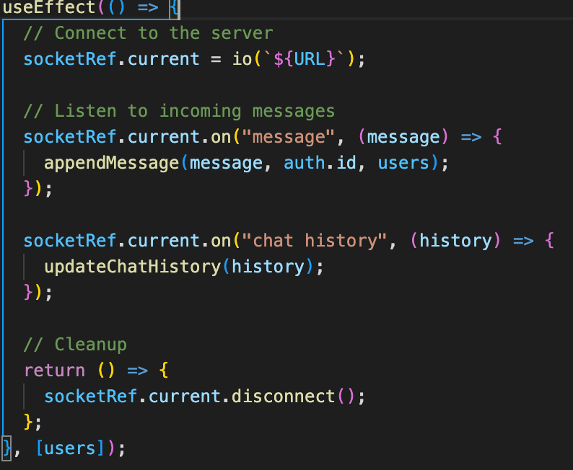

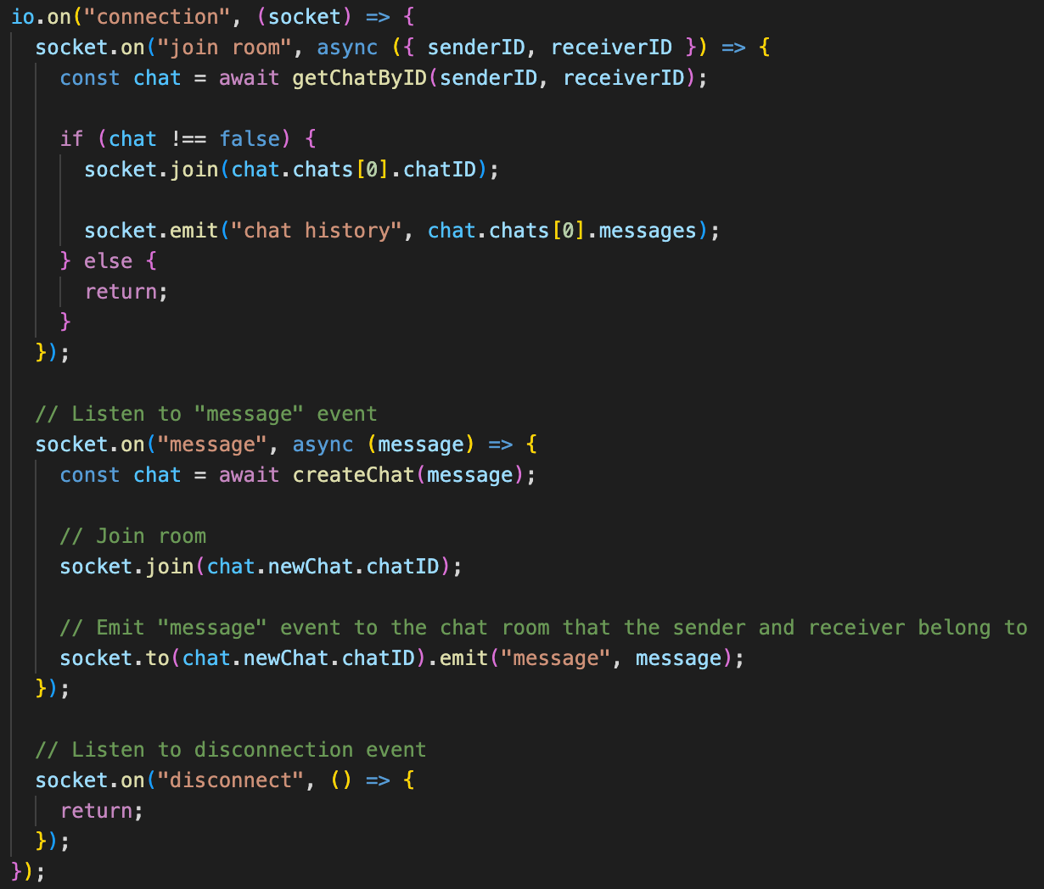

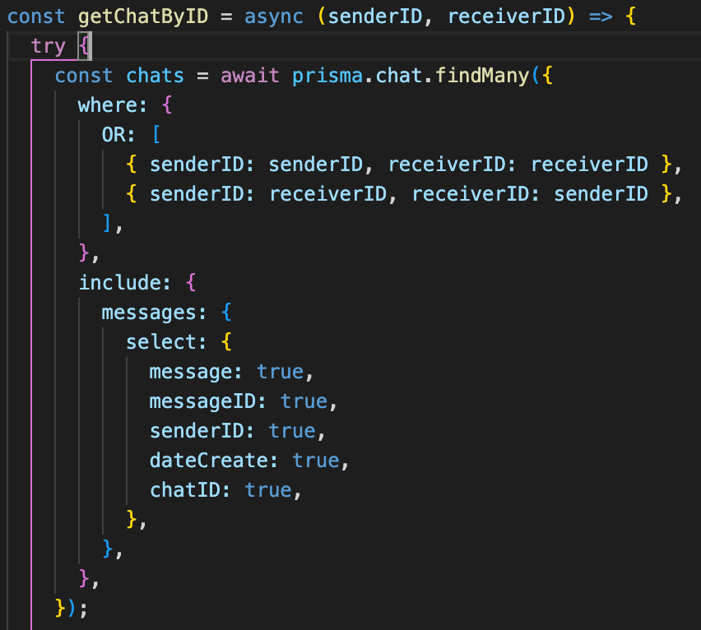

###### Figure 39: MedEire Medical Records Code

### 5.3.9 Authentication

To ensure the security of MedEire's endpoints, a middleware has been implemented to authenticate the token and prevent unauthorized access to sensitive data.

This middleware checks the JWT token on the database and sets it on local storage to verify the user's identity.

By implementing this additional security measure, MedEire can safeguard against potential attacks and unauthorized access to sensitive information.

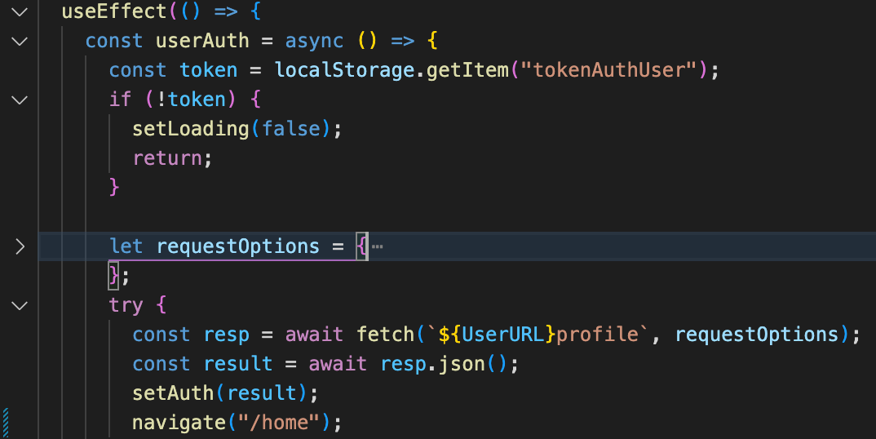

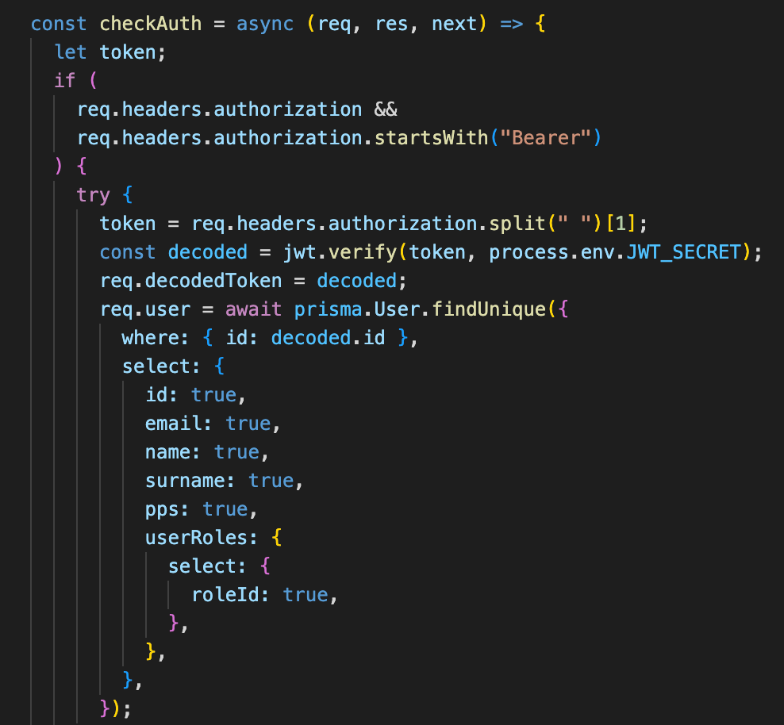

###### Figure 40: MedEire Authentication Code

### 5.3.10 Role Management

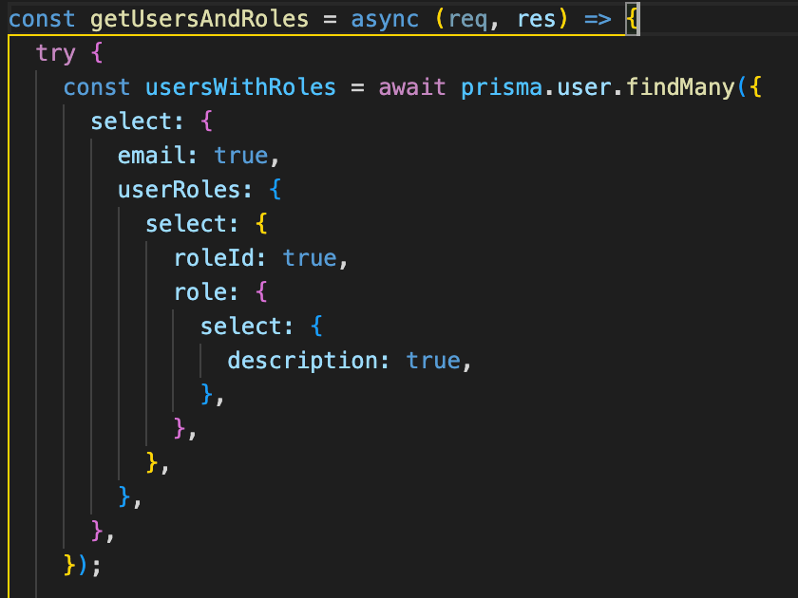

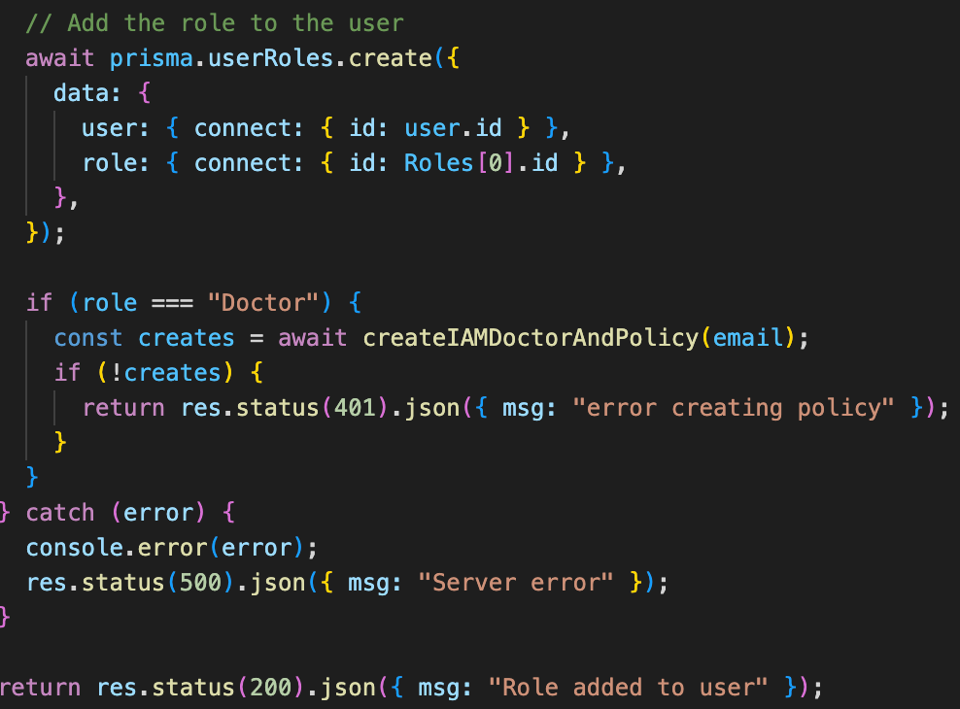

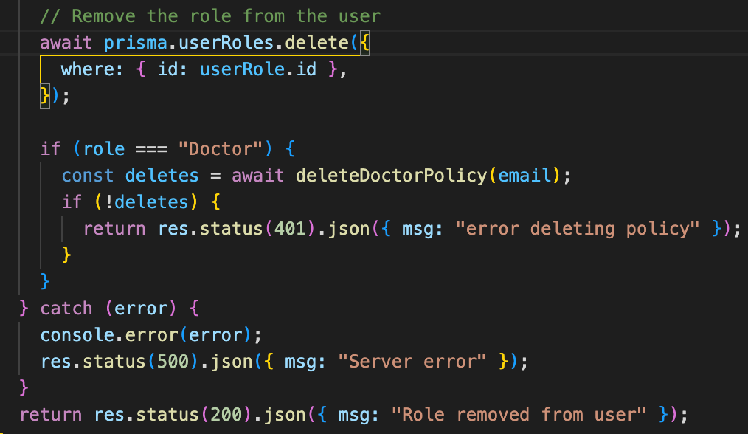

MedEire assigns a 'User' role to all users who register on the app, which provides most of the features that a patient would need.

Distinction between users relies on IT management, specifically the 'Admin' role, to add or remove roles such as 'Doctor', 'Admin', or 'User'.

API endpoints are used to find all users and roles available in the database, allowing IT users to select the user and role they would like to add or remove.

When adding roles, the database is checked to ensure that the user does not already have the added role. If the role is 'Doctor', the Doctor IAM policy is created for the selected user.

Similarly, when deleting roles, the database is checked to ensure that the user has the role to delete. If the role is 'Doctor', the Doctor IAM policy for the selected user is also deleted.

###### Figure 41: MedEire Role Management Code

## 5.4 AWS Services

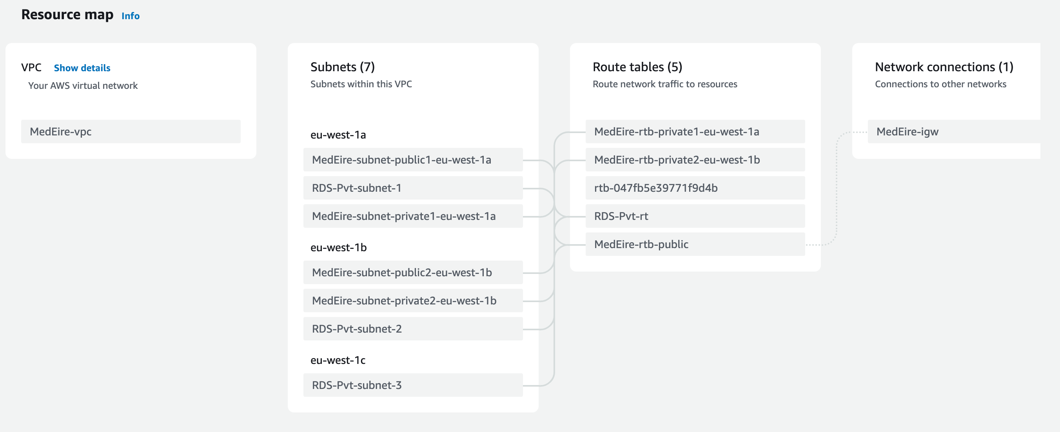

MedEire's VPC implementation incorporates several security measures to ensure the protection of all routes and connections. The setup includes seven subnets, with two private subnets dedicated to RDS, one in each of the eu-west1a and eu-west1b availability zones, and an additional private subnet in eu-west1c. Five route tables are implemented, with two public and three private tables, ensuring that traffic is routed through secure channels. An internet gateway is also included in the setup, enabling secure external communication. Together, these features work to ensure that MedEire's VPC is secure and reliable.

###### Figure 42: MedEire VPC

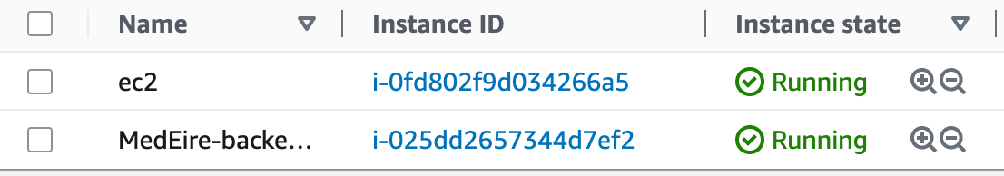

MedEire's server is hosted on two EC2 instances, one for the backend server and the other for facilitating database connections, ensuring efficient data management and reliable security. The server setup utilizes NGINX as a reverse proxy, with SSL encryption provided by Certbot - Let's Encrypt, and HTTPS for secure data transfer. pm2 is also utilized as a service, ensuring reliable server operation. This setup enables secure and efficient server performance for MedEire.

###### Figure 43: MedEire EC2

MedEire's RDS uses MySQL and implements secure access by only allowing connections from the designated EC2 instance and my IP address. This ensures that data is protected from unauthorized access and helps maintain the integrity of the system.

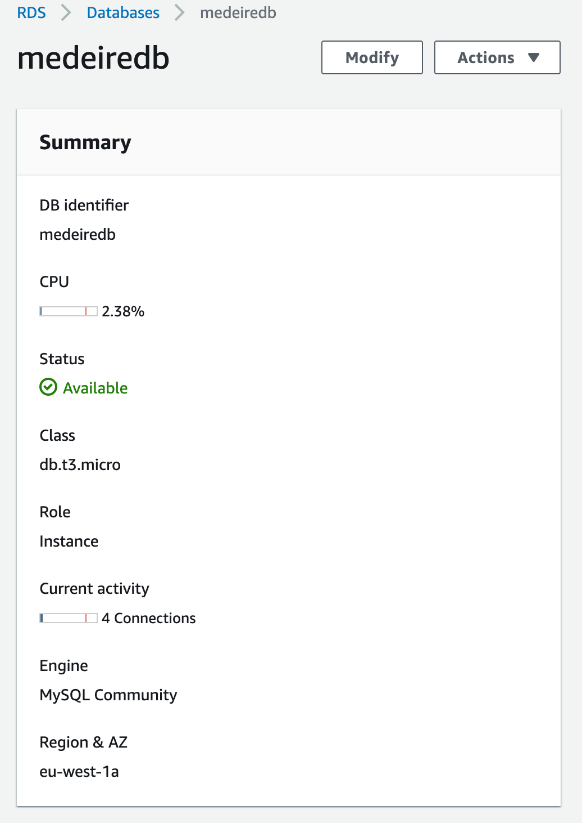

###### Figure 44: MedEire RDS

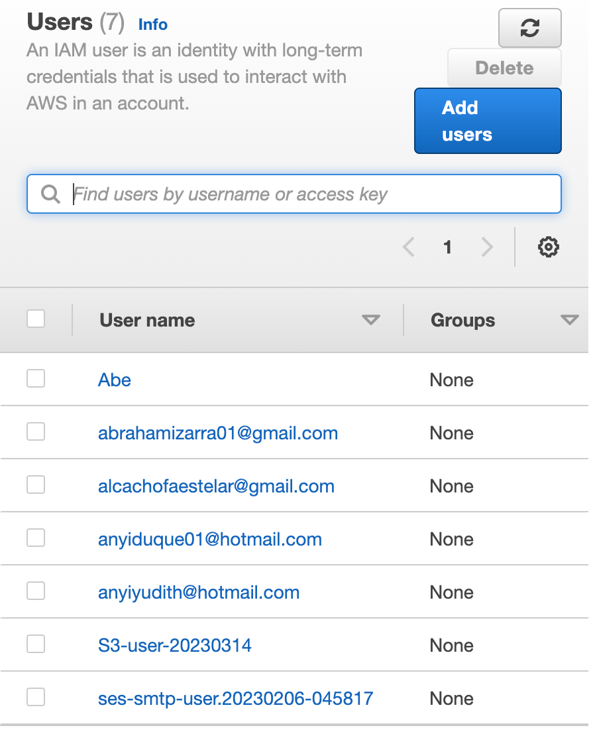

MedEire utilizes IAM Users to manage access control and user permissions.

When a user registers on the platform, a new user is created on IAM with specific roles and permissions tailored to their role.

This ensures the privacy and security of files and accounts. In cases where a user does not have an email address, MedEire creates the necessary IAM User accounts, roles, and permissions using the principle of least privilege, ensuring that access is restricted to only what is necessary for each user.

###### Figure 45: MedEire IAM Users

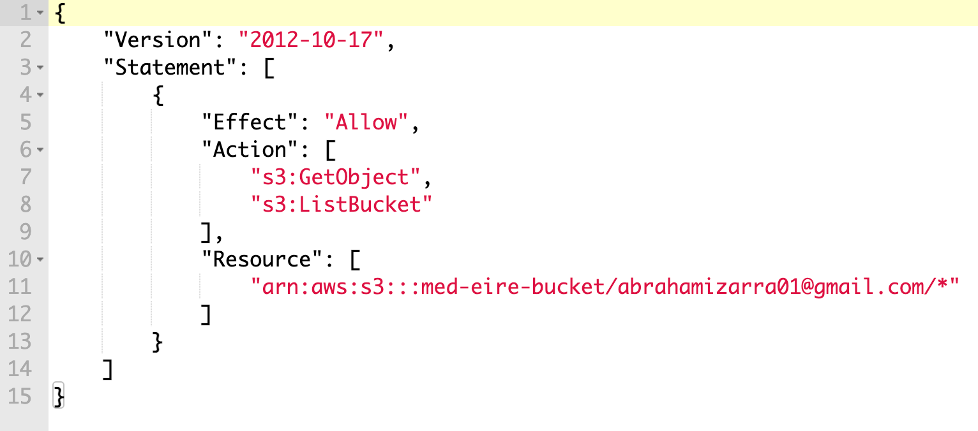

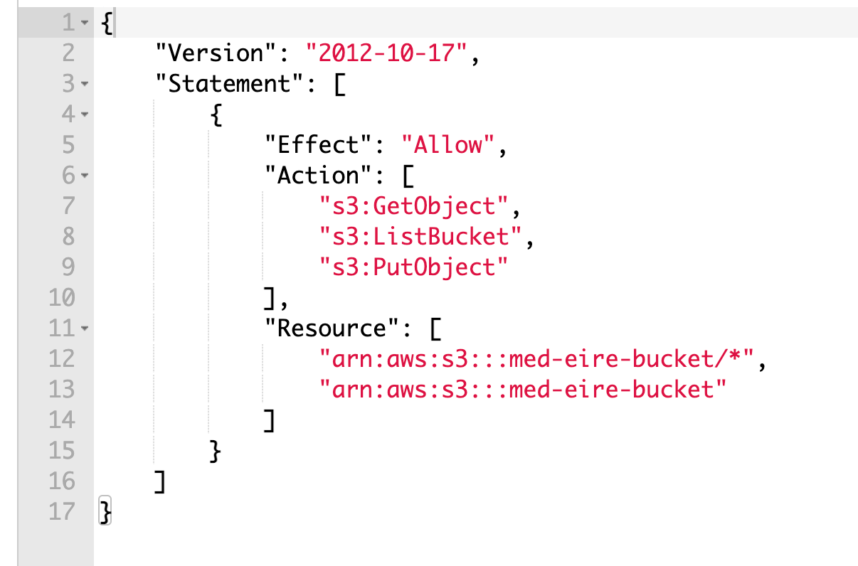

MedEire utilizes IAM Roles to manage user access to the S3 bucket.

When a user registers, they are assigned a patient policy that restricts them to only view and download files from their folder.

If the user is a staff member, a different IAM Role is added to their account, which grants them access to view, download, and upload files in all folders within the S3 bucket.

This ensures that user access is limited to only what is necessary based on their role and responsibilities within the system.

###### Figure 46: MedEire IAM Roles

MedEire utilizes SES (Simple Email Service) to send various types of emails, including authentication emails during registration, appointment creation and rescheduling notifications, and email verification to allow users to log in. By using SES, MedEire can ensure that all emails are sent securely and reliably, minimizing the risk of unauthorized access or data breaches. SES also enables MedEire to track email delivery and provides analytics on email engagement, which can help improve the efficiency and effectiveness of email communications.

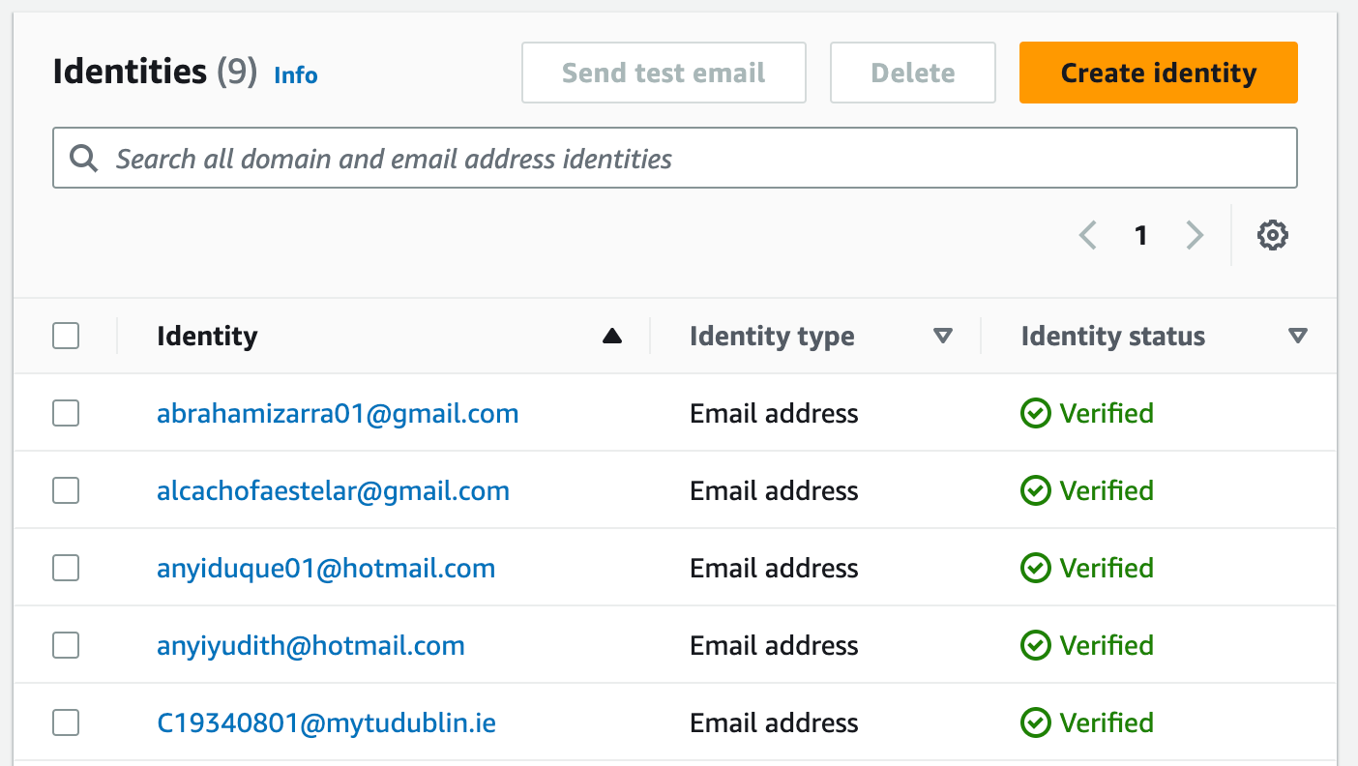

###### Figure 47: MedEire SES

MedEire uses S3 (Simple Storage Service) to create individual folders for each user, allowing for secure and organized file storage. To ensure the confidentiality and integrity of stored files, MedEire also implements SSE (Server-Side Encryption) encryption. This added layer of security helps protect against unauthorized access and data breaches. By utilizing S3 and SSE encryption, MedEire can provide a secure and efficient file storage system for its users.

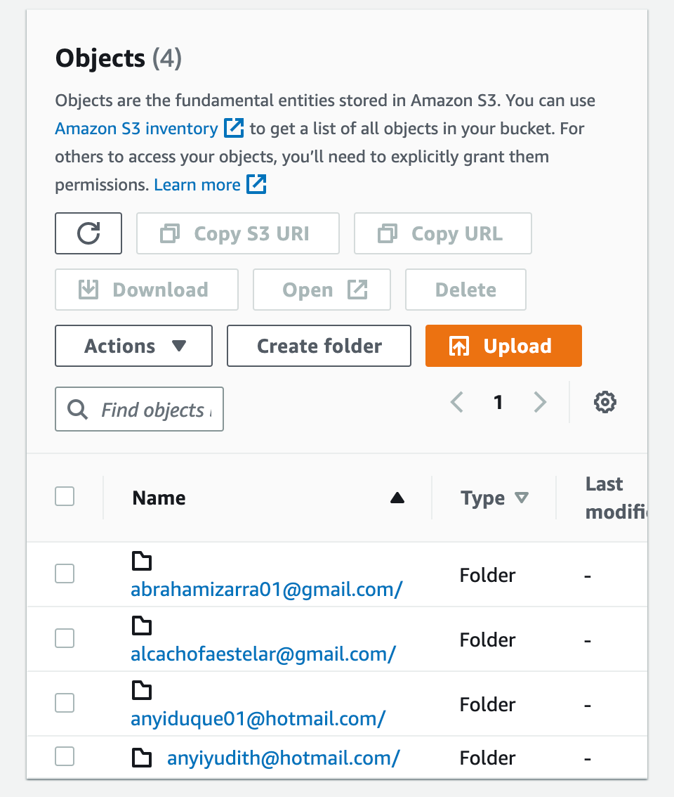

###### Figure 48: MedEire S3

MedEire hosts its frontend application on Amplify, ensuring extra security with SSL encryption. It uses a custom domain from GoDaddy.com to provide users with a personalized domain name. This setup provides a secure and reliable user experience for the frontend application.

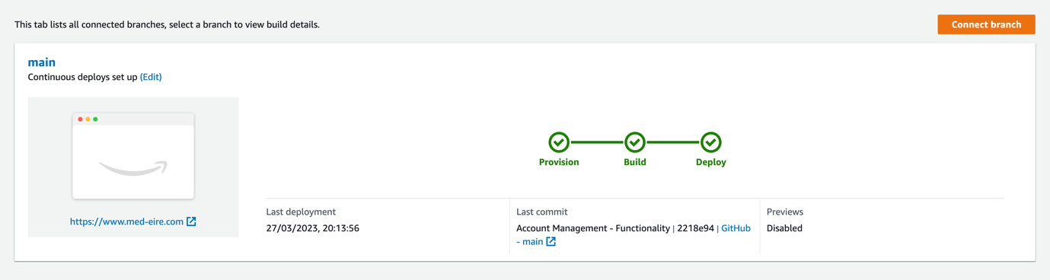

###### Figure 49: MedEire Amplify

## 5.5. Conclusions

MedEire has successfully completed the first phase of its development. Although the task manager feature is not fully functional in this phase due to time constraints, the planning is to incorporate it in the next stage of the MedEire’s development. This feature will enhance the overall functionality and user experience of the app.

Despite this temporary limitation, MedEire has made significant progress towards its goal of creating an innovative and useful healthcare app.

The app's existing features, such as the appointment scheduler, live chat, medical Record, are already proving to be valuable tools for patients and healthcare providers alike.

The incorporation of the main prototype's design and features was a crucial step towards the final product, and the emphasis on a reliable system, appropriate tools, and cybersecurity measures.

The prototype played a critical role in enabling the testing and refinement of features and designs before the final stage, allowing for timely corrections and modifications.

The feedback received from both medical staff and patients regarding the MedEire was overwhelmingly positive, with many users noting the platform's solid mobile responsiveness and user-friendly interface.

The website was praised for its ease of use, and many users found it simple to create, reschedule, and cancel appointments.

One suggestion was to add a cancellation list that would enable patients to fill up any available appointment slots if someone else cancels on the day. Another recommendation was to provide clearer registration instructions, including advising users that logging is case-sensitive.

In addition, staff users suggested adding live chat notifications feature to alert users when they receive a response to their chat. It was also suggested that staff members should not be able to see other staff members' PPS on the ‘select PPS’ list and that the patient's name should be displayed alongside their PPS number in scheduled appointments. The chat online/offline status also needs improvement.

Furthermore, users suggested that the Task Manager needs improvement and that chat alerts should be added. The ability to delete files from patient records would also be a useful feature.

Overall, the website was well received by both medical staff and patients, but there is room for improvement to provide a more efficient and user-friendly experience. The suggestions provided by users could be implemented to enhance the platform's functionality and improve the user experience.

For first-hand experience you can visit the link below to bring you into MedEire’s app.

<https://www.med-eire.com>

# 6. Issues and Future Work

## 6.1. Introduction

Throughout the project, some problems and barriers were discovered that intervened in the implementation of the project. The main barrier was the high investment cost of one of the applied technologies. In addition, the possible risks that could be part of the obstacle during the project are discussed. Including a brief explanation of everything related to potential new features and improvements in the future of MedEire.

## 6.2. Issues and Risks

### 6.2.1 Budget

One of the technologies used is Amazon Web Services (AWS), which was chosen because it offers more advantages, is more affordable, and, as a bonus, offers a free tier with $100 credit for students. Nevertheless, once the development of the project began, one of the obstacles presented was that the free credit for students was no longer available. Because there is a limited budget, this implies that more time should be spent conducting new research on the potential changes to implement.

### 6.2.2 Security

MedEire, is storing user IDs in the token on local storage, which can be vulnerable to cross-site scripting attacks. To mitigate this risk, the plan is to improve the security by the transition to web-only cookies in future iterations.

This approach will help ensure that the user's sensitive information is kept secure and inaccessible to any potential attackers.

As part of cybersecurity, web application security focuses on safeguarding websites, web-based applications, and online services from a variety of malicious attacks, ensuring their smooth operation and performance. One of the main focuses is to prevent risks to the security of data and systems. However, it is always one of the aspects that must be considered as a risk.

### 6.2.3 Time

During the initial development phase, all the planned features were successfully implemented on the patient side of the platform.

However, due to time constraints, MedEire was unable to fully develop all the features for medical professionals. While appointment creation, cancellation, and editing, medical record upload, and live chat functions were successfully implemented, the task manager feature is not fully functional at this stage.

### 6.2.4 Registration Email (authentication)

MedEire is currently using AWS SES to send authentication emails. As the app is not yet on production, the email has an Amazon template that cannot be customized until the application is moved to a production account.

## 6.3. Plans and Future Work

MedEire is an ambitious project that seeks to transform the healthcare sector by leveraging cutting-edge technology.

The project's primary objective is to provide patients and medical professionals with a seamless and user-friendly platform for scheduling digital appointments and managing medical records.

While the prototype has been completed successfully and achieved its intended objectives, there is still room for improvement in some areas. Specifically, the task manager feature, which was included in the application, is not yet fully functional. As such, further development and refinement will be necessary to ensure that this feature is fully functional and meets the needs of users.

Additionally, the design of the application could benefit from some improvements. Specifically, there is a need to enhance the overall aesthetics and user experience of the platform.

This could involve incorporating more visually appealing graphics, improving the layout and organization of information, and streamlining the user interface to make it more intuitive and easier to use.

Overall, while the prototype for MedEire represents a significant step forward in the digital transformation of the healthcare sector, there is still work to be done to refine and enhance the platform's functionality and user experience.

With continued development and improvement, MedEire has the potential to revolutionize the way patients and medical professionals interact and engage with the healthcare system.

In this regard, future services that might be added to MedEire have been considered, the list below gives a general overview of these traits:

### 6.3.1 Home emergency

This extra feature is a call emergency system intended for elderly patients. The intention is to develop a communication system, utilizing a button-controlled device that connects to MedEire. When the button is pressed, it sends a notification to the medical staff in MedEire with the patient's name and location via GPS.

### 6.3.2 Add online payment:

The advantages of digital payments are numerous, and consumers are demanding faster, safer, and more convenient payment methods. MedEire has been created to impact positively in the health sector, support people and improve their life quality. Digital payments are extremely low risk and offer a higher level of payment protection thanks to cutting-edge technology and strict security. Making online payment functionality available is one of the ways to continue generating improvements in MedEire.

## 6.4 GANTT Chart

Below (Figure 50) are the dates for implementation of features and tools for MedEire, the project started in mid-October and its final submission is to be on the 31st of March, with the final presentation to be around mid-April.

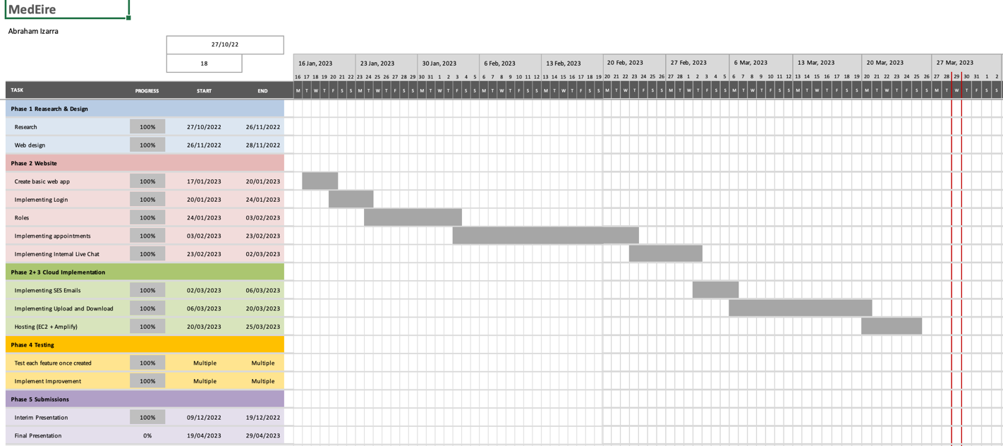

###### Figure 50: MedEire Gantt Chart Showing the Implementation Dates of Features and Tools

# 

## 6.5 What Would have been done differently.

MedEire project was an ambitious undertaking that successfully accomplished most of its proposed goals. The project was both captivating and educational, as it provided ample opportunities for learning. However, it should be noted that certain aspects of the project could have been approached differently, particularly regarding the creation of the application.

Given the limited budget, the use of alternative services such as EC2 instances was necessary; however, the use of Beanstalk may have provided a more efficient solution.

Additionally, an alternative approach that could have been considered for building the server of MedEire is utilizing the Amplify framework. This approach may have offered increased flexibility, security, and scalability.

# Bibliography

1. Abrahamsson, P., Warsta, J., Siponen, M.T. & Ronkainen, J. (2003) “New directions on agile methods: a comparative analysis”, Proceedings of the 25th International Conference on Software Engineering (ICSE’03)
2. Shannon, June. “The ‘workhorses’ of the Health Service: How Ireland’s GPs Are under Increasing Pressure Right Now.” TheJournal.ie. Accessed November 28, 2022. <https://www.thejournal.ie/shortage-of-gps-in-ireland-5758511-May2022/>.
3. Danny, Rigg. “Doctors Explain Why It’s so Hard to Get a GP Appointment - Liverpool Echo.” Accessed November 28, 2022. <https://www.liverpoolecho.co.uk/news/health/doctors-explain-its-hard-gp-24654752>.
4. Irish Examiner, “Irish Examiner: Are You Struggling to Find a GP or Get a Doctor’s Appointment?” Irish Examiner, September 22, 2021. <https://www.irishexaminer.com/news/arid-40703885.html>.
5. Gackenheimer, C. and Paul, A., 2015. Introduction to React (Vol. 52). Apress.
6. Eisenman, Bonnie. Learning React Native: Building Native Mobile Apps with JavaScript. O’Reilly Media, Inc., 2017.
7. Sacha Greif and their team, 2022. “The State of JS 2021.” Accessed November 3, 2022. <https://2021.stateofjs.com/en-US/>.
8. Hahn, Evan. Express in Action: Writing, Building, and Testing Node.js Applications. Simon and Schuster, 2016.
9. Stack Overflow. “Stack Overflow Developer Survey 2022.” Accessed November 25, 2022. <https://survey.stackoverflow.co/2022/?utm_source=social-share&utm_medium=social&utm_campaign=dev-survey-2022>.
10. Wittig, Michael, and Andreas Wittig. Amazon Web Services in Action. Simon and Schuster, 2018.
11. Synergy Research Group, 2022. “Q2 Cloud Market Grows by 29% Despite Strong Currency Headwinds; Amazon Increases Its Share”. Accessed November 8, 2022. <https://www.srgresearch.com/articles/q2-cloud-market-grows-by-29-despite-strong-currency-headwinds-amazon-increases-its-share>.
12. Tankariya, Vipul, and Bhavin Parmar. AWS Certified Developer – Associate Guide: Your One-Stop Solution to Passing the AWS Developer’s 2019 (DVA-C01) Certification, 2nd Edition. Packt Publishing Ltd, 2019.
13. Murty, James. Programming Amazon Web Services: S3, EC2, SQS, FPS, and Simple DB. O’Reilly Media, Inc., 2008.
14. Kulkarni, G., Sutar, R. and Gambhir, J., 2012. Cloud computing-Infrastructure as service-Amazon EC2. International journal of Engineering research and applications)
15. Shackelford, Adam. Beginning Amazon Web Services with Node.js. United States, Apress, 2015.
16. Dabit, Nader. Full Stack Serverless. United States, O'Reilly Media, 2020.
17. Wilton, Paul. Beginning JavaScript. John Wiley & Sons, 2004.
18. Chaffer, Jonathan. Learning JQuery - Fourth Edition. Packt Publishing Ltd, 2013.

1. <https://www.barnaclinic.com/en/solicitar-cita/>
2. <https://opinaesteticas.com/barcelona/barcelona/barnaclinic/>
3. <https://mychart.hopkinsmedicine.org/MyChart/Authentication/Login?postloginurl=Scheduling>
4. <https://www.siliconrepublic.com/start-ups/letsgetchecked-funding-morgan-health-series-d-expansion>
5. <https://www.finsmes.com/2022/09/letsgetchecked-receives-20m-investment-from-morgan-health.html>
6. <https://techcrunch.com/2017/04/18/facebook-announces-react-fiber-a-rewrite-of-its-react-framework/>.
7. <https://thecodest.co/blog/pros-and-cons-of-react>.
8. <https://www.tatvasoft.com/outsourcing/2022/02/top-10-successful-companies-using-react-js.html>
9. <https://www.simplilearn.com/tutorials/reactjs-tutorial/routing-in-reactjs>
10. <https://www.pluralsight.com/guides/pros-and-cons-of-client-side-routing-with-react>
11. <https://javascript.plainenglish.io/the-pros-and-cons-of-node-js-web-app-development-a-detailed-look-c91a22f013c>
12. <https://www.altexsoft.com/blog/engineering/the-good-and-the-bad-of-node-js-web-app-development/>
13. <https://data-flair.training/blogs/aws-advantages/>.
14. <https://intellipaat.com/blog/aws-benefits-and-drawbacks/>
15. <https://www.ibm.com/cloud/blog/sql-vs-nosql>.
16. <https://sarasanalytics.com/blog/amazon-rds-pros-and-cons/>
17. <https://codeburst.io/amazon-s3-pros-cons-and-how-to-use-it-with-javascript-701fffc89154>
18. <https://codeburst.io/amazon-s3-pros-cons-and-how-to-use-it-with-javascript-701fffc89154>
19. <https://supporthost.com/amazon-ses/>
20. <https://www.blazeclan.com/blog/facts-about-amazon-ses-disadvantages-advantages-pricing/>
21. <https://beabetterdev.com/2021/09/22/what-is-aws-amplify/>
22. <https://medium.com/analytics-vidhya/what-is-aws-amplify-advantages-and-disadvantages-of-aws-amplify-49ddc4831467>
23. <https://www.section.io/engineering-education/understanding-socket/>
24. <https://ably.com/topic/socketio-vs-websocket#socket-io-pros-and-cons>
25. <https://ably.com/topic/socketio-vs-websocket#socket-io-pros-and-cons>
26. <https://www.pangea.ai/dev-javascript-resources/best-practices/>.
27. <https://www.hitechwhizz.com/2022/07/6-advantages-and-disadvantages-drawbacks-benefits-of-jquery.html>.
28. <https://www.simplilearn.com/tutorials/azure-tutorial/what-is-azure>
29. https://www.qulix.com/about/pros-and-cons-of-azure/
30. <https://crm-masters.com/google-cloud-platform-advantages-and-disadvantages/>
31. <https://medium.com/dailyjs/google-cloud-storage-pros-cons-and-how-to-use-it-with-javascript-ea9ce60a94c0>
32. https://www.mongodb.com/nosql-explained
33. <https://www.adservio.fr/post/what-are-the-pros-and-cons-of-nosql>
34. <https://library-cc.tudublin.ie/search?/dtu857/dtu857/1%2C2%2C66%2CB/frameset&FF=dtu857+dissertations+dt211c+bsc+hons+in+computer+science&6%2C%2C33>
35. <https://library-cc.tudublin.ie/search?/dtu857/dtu857/1%2C2%2C66%2CB/frameset&FF=dtu857+dissertations+dt211c+bsc+hons+in+computer+science&16%2C%2C33>
36. <https://www.designveloper.com/blog/pros-and-cons-of-agile-methodology/>
37. <https://www.designveloper.com/blog/pros-and-cons-of-agile-methodology/>
38. <https://www.synopsys.com/blogs/software-security/top-4-software-development-methodologies/>
39. <https://www.one-beyond.com/pros-cons-waterfall-software-development/>
40. <https://www.one-beyond.com/pros-cons-waterfall-software-development/>
41. <https://distantjob.com/blog/rad-model-advantages-and-disadvantages/>
42. <https://www.guru99.com/what-is-rad-rapid-software-development-model-advantages-disadvantages.html>
43. <https://www.guru99.com/what-is-rad-rapid-software-development-model-advantages-disadvantages.html>